A cross-case analysis of six community-based programs in Ontario’s Literacy and Basic Skills system

Digital Access, Inclusion and Learning in Community Adult Literacy Centres

Christine Pinsent-Johnson
AlphaPlus is a not-for-profit organization that provides training, services, tools and resources to adult literacy agencies and educators in Ontario and Canada. Its mission is to increase adult literacy skills and the employability and opportunities of adults through the use of digital technologies by supporting educators and stakeholders with research, tools and training.
Abstract
AlphaPlus oversaw a cross-case analysis of digital inclusion and digital literacy development in six community literacy centres in Ontario, which receive funding from the Ministry of Advanced Education and Skills Development (MAESD) Literacy and Basic Skills (LBS) program. The literacy centres, situated directly in small towns, cities and remote communities throughout Ontario, play a key role in supporting the province’s digital transformation initiative and its commitment to ensure an “inclusive digitally enabled province.” The centres provide various learning opportunities for digitally marginalized adults — adults living in poverty, the unemployed or precariously employed, those with limited education and some older adults. They use various models of digital literacy development to respond to learners’ array of digital literacy experiences and aspirations. However, this work is not currently part of a broader provincial digital inclusion strategy. In addition, professional development opportunities and educator training are inconsistent across the system. LBS eligibility criteria and enrolment targets can interfere with the ability of community organizations to be fully inclusive and responsive to digitally marginalized adults, particularly older adults and those not actively looking for work.

Digital Access, Inclusion and Learning in Community Adult Literacy Centres
Licensed under the Creative Commons Attribution-NonCommercial 4.0 International License.
To view a copy of this licence, visit http://creativecommons.org/licenses/by-nc/4.0/
Published by AlphaPlus, Toronto, Ontario, October 2018. Download at www.alphaplus.ca
This research was supported by the Government of Ontario through the Ontario Human Capital Research and Innovation Fund. For more information on the initiative, visit http://www.tcu.gov.on.ca/eng/eopg/programs/ohcrif.html

Contents
Executive Summary 1
Introduction 3
Overview of the Digital Divide 4
1. Life Events and Increasing Digital Demands 12
2. Socio-Economic Challenges and Access Barriers 16
3. Learners’ Digital Literacy and Learning Experiences 19
4. Organizational and Instructional Approaches 27
5. Professional Practices and Curriculum Development 38
6. Programs Address Policy and Program Operation Concerns 42
Next Steps 52
Appendix 1: Research Methodology 53
Appendix 2: Program Overviews 60
Program 1 60
Program 2 61
Program 3 62
Program 4 63
Program 5 64
Program 6 65
Appendix 3: Overview of Applications Mentioned 66

Executive Summary
AlphaPlus oversaw a cross-case analysis of digital inclusion and digital literacy development in six community literacy centres in Ontario, which receive funding from the Ministry of Advanced Education and Skills Development (MAESD) Literacy and Basic Skills (LBS) program. The literacy centres, situated directly in small towns, cities and remote communities throughout Ontario, play a key role in supporting the province’s digital transformation initiative and its commitment to ensure an “inclusive digitally enabled province.” The centres provide various learning opportunities for digitally marginalized adults — adults living in poverty, the unemployed or precariously employed, those with limited education and some older adults. They use various models of digital literacy development to respond to learners’ array of digital literacy experiences and aspirations.

How the Programs Currently Support Inclusion and Digital Literacy
- Life events and rapidly increasing digital demands propel 13,000 Ontarians into community literacy centres each year to access learning and digital development opportunities, leveraging skills, knowledge and understandings for personal, educational and job-related purposes.
- Programs recognize and do what they can to respond to broader
socio-economic challenges (i.e. poverty, employment shifts, lack of transportation, and limited and/or costly home internet access) and individual circumstances (i.e. disabilities and mental and physical health challenges) that impede digital inclusion and literacy development.
- Learners have an array of digital literacy and learning experiences, repertoires and aspirations. Some have little to no experience with technology, while others have extensive expertise in one area that has become obsolete or undervalued in the labour market.
- Programs develop and integrate various models of digital inclusion that are supported by caring learning relationships, providing numerous examples of responsive and meaningful programming.
- They also use technology to enhance, reorganize and even reinvent their models of delivery, often to maintain their community development and individual transformation aims.
- Without a comprehensive professional development strategy, educators draw on their personal repertoires of technical expertise and share their own resources to support professional practices and develop curricula.
- Targeted content development, with clearly defined aims and outcomes,
is more straightforward than everyday and academic literacy development.
- Programs streamline, supplement and develop workarounds to accommodate the administrative demands required by the funder.

Enhancing the Role of Community Learning Organizations
The six community literacy organizations, built on a tradition of community development and social inclusion, provide both insights into and useful models of digital inclusion. With some additional support and within the context of a digital inclusion strategy for Ontario, community literacy organizations are well-positioned to contribute to the province’s digital transformation initiative.

Ontario Digital Inclusion
The Government of Ontario released an action plan September 2018 outlining the steps it will take to create a digitally driven government. The digital transformation effort will not only involve more seamless online interactions but also includes efforts to re-design government structures.
We must take a more holistic approach, addressing both how we design, deliver and operate new technological solutions to human problems, as well as adapt existing technological solutions and infrastructure to meet modern needs (p. 7).
Digital inclusion and equity are one of their ten priorities. They aim to address inequities through design, addressing connection challenges in rural and remote communities, providing internet access in public places, supporting the development of “essential digital skills” across the lifespan, and helping people use technology to “address local problems in their communities” (see pages 15-16 of the action plan).
From Start with users. Deliver together. Ontario’s path to simpler, faster, better government, The Government of Ontario, September 2018.

Targeted policy changes could be made to better support professional and
program development.
- Introduce a way for educators to access ongoing professional development opportunities, including collaboration with peers, access to expertise
and time to innovate and experiment with new technology and
learning approaches.
- Support educators to become adept digital curators; in addition, collaborative curation projects could make the most out of limited resources.
- Recognize and support the numerous ways that programs integrate technology with current instructional models (i.e. learning groups, classes, short courses and one-to-one) and to respond to complex content and access considerations (i.e. challenges being on-site, no content repository or regular content development initiatives).
- Better articulate adult literacy development to recognize that adults live, work and learn in a multi-modal world in which there are access and inclusion barriers.
- Review current learner targets and suitability indicators that deem some participants to be less countable in the system, such as older adults and those not actively looking for work.
- Consider the development of digital human capital and digital citizenship to buttress an inclusive digital transformation effort that includes competency development in the areas of civic engagement, policy influence, social change and economic advancement.

Introduction
People’s literacy, put to use online and on paper, is a highly valued resource in an economy that is rapidly moving away from manufacturing things to manufacturing symbols — information, knowledge and communication that support the production, delivery and management of goods, services and natural resources. Even if we are not directly involved in the manufacturing of symbols and information for pay, we are the end-users of technological and symbol-based systems designed to deliver the goods and services we use each day (think of scheduling, purchasing, entertainment, accessing services, finding employment
and navigating institutional structures like healthcare and education).
An example of an end-user change, most relevant to this project, is Ontario’s digital transformation, which will alter the way government interacts with the public and provides services. Transformation efforts involve the development of new digital solutions to address enduring issues and provide ways to directly involve citizens in decision-making. Not directly stated in the promotion of digital change projects are the increased responsibilities expected of citizens to navigate and access services as processes once completed by paid employees are downloaded. Not only will individuals have to take on this work, but human assistance and guidance may not be readily available.
An important part of the province’s digital transformation efforts is a commitment to ensure an “inclusive digitally enabled province.” It is within this context that we pursued two projects to explore digital inclusion and digital literacy. The first project, a literature review, looked at barriers to digital inclusion and the persistence of a digital divide in Canada and Ontario, along with some policies and practices that could alleviate the divide.
The second project, and focus of this report, explores the various ways that six community literacy centres in Ontario support digital inclusion and digital literacy development. Accompanying the report is a separate document with more details of each program.

Overview of the Digital Divide
Canada has one of the largest divides among Organization for Economic
Co-operation and Development (OECD) member countries, according to an international assessment overseen by the OECD. We also have one of the largest proportions of the population scoring at the lowest level in the technology-related skill assessment (15% of Canadian adults compared to 16% of Americans and only 9% of Australians).

Figure 1. Canada’s digital skill divide compared to other OECD countries
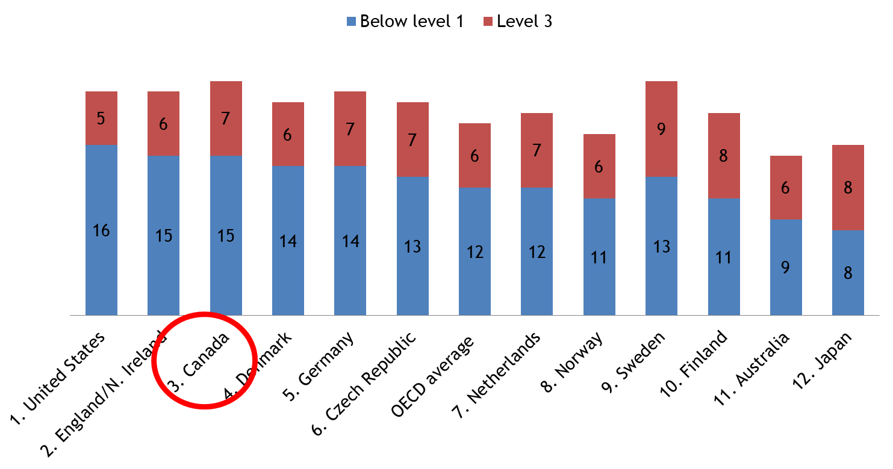
Access to affordable connections and devices, relevant and sustained learning supports, and opportunities to leverage skills to benefit and reshape individual circumstances are unevenly available to adults — all of which are reflected in international test results.

Access and Affordability, Learning Supports and Benefits
Digitally marginalized adults are those who already experience social and economic inequality related to age, income, education, living in rural and remote communities, and immigration. While nearly all Canadian households (97%)
with an income above $94,000 have a home internet connection, less than half (46%) with household incomes under $30,000 are online. And less than a third of low-income seniors have a home connection.

Digital Literacy within the Context of Digital Inclusion
Digitally included individuals can use computers, smartphones or tablets for transactions with businesses or governments, for communication, to create and consume entertainment and to access information about anything they wish. That is, they can make use of these digital communication tools to be part of society. Given the prevalence of digital means of interaction, western societies are now often described as digital societies. Digital societies are supported by digital economies and populated by digital citizens.
The internet is the location for many digital activities, as it allows communication between individuals and organizations across large or small distances. To be digitally included, citizens must have internet access with broadband internet — that is, fast internet. So understanding the nature of internet access is important to any investigation of digital inclusion. Digital inclusion also requires that people can make use of the technologies to which they have access, meaning that the technologies should be affordable and simple to learn how to use. Digitally literate people know how to use digital technologies in ways that realize benefits and in ways that are secure and protect their privacy. Digital literacy allows individuals to fully participate in digital society. When combined with good internet access, digital literacy enables digital inclusion.
From There’s an App for That. Unless There Isn’t — The Challenges of Digital Inclusion in Canada in 2016 by Catherine Middleton, Canada Research Chair in Communication Technologies in the Information Society, Ted Rogers School of Management, Ryerson University.

Although inequalities within society have always existed, the internet created an even stronger division; the higher-status members increasingly gain access to more information than the lower-status members. The internet is not only an active reproducer of social inequality but also a potential accelerator.
Ensuring affordable access to devices and connections is the first step needed to address current digital inequities. In addition, relevance, digital literacy and trust will shape how and if people become fully engaged in online environments. Participation in post-secondary education, employment and additional employer-supported training enhances adults’ repertoires of digital skills and knowledge.
But what happens to those who have little or no access at home, aren’t continuously employed, are retired or haven’t been recently engaged in an education program? How do they hone their skills and build their repertoires?

Digital Literacy Development Opportunities
There is an uneven landscape of digital access and engagement opportunities for adults outside of employment and post-secondary education. Canada currently has no national affordability and engagement strategy to support digital inclusion.
A national report from the Brookfield Institute for Innovation + Entrepreneurship recently also highlighted some of the barriers to digital access and opportunities for the “underserved.” Despite calls for the “development of a comprehensive digital strategy offering a vision of how digital technologies can be used to improve delivery of services across all levels of the economy ... and improving quality of life in Canadian communities,” there was no discussion of affordability when the federal government announced funding for broadband improvements in late 2016. Although some federal funding for digital literacy was announced in 2018, it is only for short-term projects.
In Ontario, opportunities are currently unco-ordinated and uneven, often dependent on sporadic government funding or limited corporate initiatives.
This has resulted in disparate access to infrastructure and digital learning supports and expertise.
Public libraries provide one of the most accessible points of infrastructure in cities, but this can be more uneven in rural areas. They also have limited learning supports. Similarly, the province’s employment service centres can provide some infrastructure for those actively seeking employment but offer no sustained learning supports. Neither are ideal solutions; people need home internet connections and devices to support regular engagement and digital literacy development. Currently, there is no universal household internet-access program for those who receive income assistance or have very low incomes.
The Ontario government also funds a range of adult learning programs co-ordinated by three different ministries (illustrated in Figure 2) that integrate digital technology to varying degrees and for a variety of learning purposes. However, there is no overall vision to develop digitally inclusive access to learning opportunities in a sustained and growth-oriented manner within and across
these programs.
Figure 2. Ontario adult education programs and ministry funders
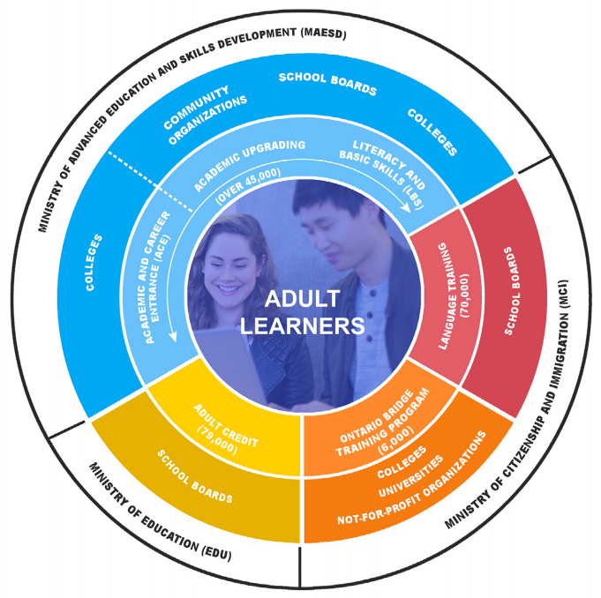
One of the most potentially inclusive programs is Literacy and Basic Skills (LBS), particularly those programs that are offered by community organizations. Community programs are not aligned with an educational institution and have traditionally strived to ensure inclusivity for digitally and educationally marginalized adults in the communities they serve.
Community-based learning and literacy centres for adults can be found throughout the province. They are non-profit organizations and may be located within a community service organization or co-located with an employment service agency. Many operate independently, sometimes offering walk-in support in street-level buildings. Community LBS programs do
not have an entry level requirement, nor
do they have an exclusive learning focus, and they can accommodate adult learners with a vast array of digital and print literacy experiences and interests, often working with those who have minimal experience. Six of these programs are the focus of
the study.

Research Questions
- How do programs address issues of digital inclusion
and equity?
- What sorts of digital literacy initiatives (i.e. classes, program, course, projects
or curricula) have they developed?
- How do they mediate digital and print-based literacy development?
- How do they help leverage digital literacy to benefit digitally and socially marginalized adults?

Previous research conducted by AlphaPlus in 2012 identified some barriers within community programs that could interfere with their capacity to provide learning opportunities. Those barriers include poor infrastructure, a lack of IT support to maintain and troubleshoot equipment and software, a lack of initial and ongoing professional development, and little time for staff to try new tools and methods
and collaborate.
Since then, a few changes have occurred. Importantly, programs recently received funding increases, the first ones in a decade, some of which is dedicated to updating digital equipment and infrastructure. They have also been working with a new curriculum and data management and reporting systems. The LBS system is now the focus of a multi-year “improvement and expansion” effort overseen by MAESD. It is an ideal time to revisit community organizations in order to propose evidence-based principles and insights that could inform future program and professional development initiatives.

Participating Programs
Using a multiple-case design, in which community literacy programs were examined both individually and collectively, a researcher visited six programs in the spring of 2018. Details of the study methods can be found in Appendix 1.
Sites are located in different areas of the province and in variously sized towns
and cities, serving large urban populations, smaller towns, and rural and
remote communities.
Program 1 | Located in a downtown office building shared with other social service agencies in western Ontario; operates independently
Program 2 | Street-level offices in small communities in northern Ontario; operates independently
Program 3 | Street-level location in a mid-size town in eastern Ontario; operates independently
Program 4 | Co-located with provincially funded employment services in a suburban office building with additional federal government services
Program 5 | Street-level building just outside of downtown core; operates independently
Program 6 | Street-level office in a city on the edge of the GTA; co-located with employment services and other support services
Four programs are independent organizations, one is co-located with other government services and one is part of a larger service and support organization. All receive core funding from MAESD and also access or develop additional revenue streams to supplement core funding and enhance their services and supports.
A brief overview of each program can be found in Appendix 2. In addition, we have also developed a full case study of each program in a separate document.

Report Organization
The main section of this report presents the findings of the cross-case analysis organized by the following six topics:
- Life events and rapidly increasing digital demands.
- Community socio-economic challenges.
- Learners’ digital literacy and learning experiences, repertoires
and aspirations.
- Organizational and instructional approaches of digital inclusion.
- Professional practices and curriculum development.
- Policy and program operation concerns.
Considerations for program practice, program development and policy follow each of the six sections. Some next steps are suggested at the end.

1. Life Events and Increasing Digital Demands
I'm not a computer guy, but life is forcing me to have access to technology.
The above comment was made by a learner participant in one of the programs.
Life events and rapidly increasing digital demands have propelled him and 13,000 Ontarians into community literacy centres each year to access digital development opportunities and leverage digital literacy skills, knowledge and understandings for personal, educational and job-related purposes.
Below are a few vignettes, based on interviews, providing some examples of the technical demands and changes participants encounter as they access government services, connect with friends and family, apply for a job or take a course at the secondary or post-secondary level.

Access to Government Services
The man who made the above comment participated in an interview with his wife. They both attended a computer basics course after learning about the literacy centre when they had to complete an application for the Ontario Electricity Support Program (OESP). The learning centre is an official OESP agent that can help people complete the paperwork to be eligible for a discounted hydro rate. The application is online and is very detailed, explained an instructor. As an agent, the program receives payment for each application.
When accessing government services, which could also involve a transaction, many students run into multiple barriers, explained a co-ordinator. Many online services, such as plate renewal and health card renewals, require the use of a credit card, and not all learners have one.
A major concern when accessing government services is older adults, the co-ordinator explained. They want to apply for Old Age Security (a federal service)
and they don’t have a computer or the skills to do this online. To complete an application, whether online or on paper, they need some basic navigation and manipulation skills first. The paper application (a PDF fillable form) is available online. If they want to set up an online account, they need an email account, and they need to learn how to access email from that account. They then need support signing in to and navigating the actual site. The sign-in requires credit card authentication through the affiliated bank. The layers of new learning and potential problems are overwhelming to handle without support, he added.
How many [in government] don’t know that this
will be a problem?

Connecting with Friends and Family
The same couple who learned about the program through OESP are also interested in using technology to keep in touch with their adult son who is teaching overseas. Before leaving, their son set them up with Skype on his old laptop. However, they recently started using WhatsApp on their phones, which both now prefer. The father prefers it since he can communicate with his son at any time. He also likes the challenge of learning a new application or task and has taught himself to attach files and photos. “He sends me something so I have to figure out how to respond,” he commented. The mother said she likes the app on her phone because she can see the places her son is visiting when he is travelling during school breaks.

Access to Employment
Not only will employees use technology on the job but they also have to use and sometimes demonstrate technical abilities simply to apply for a position.
A student in a different program shared her experience applying for a job with a big-box store. She had to sign up for an account to apply, which she was uncomfortable doing. “Why do I need an account? Why do I have to have a username and password just for this job?” She appeared frustrated. When she left school 30 years ago, she explained, it was so much easier to find a job.
She also questioned the type of behavioural questions posed, those designed to better understand personality traits. “Some of the questions were really out there and not related to the job.”
For example, explained another student with a similar experience, she recalled being asked the following: “If you were a fruit, what would you be?” How is someone supposed to respond to that question? she wondered.

Access to Education
The move to online learning at the secondary and post-secondary levels has introduced a new access barrier for digitally marginalized adults. A program educator who works with learners to help them complete their secondary school diploma wrote the following:
A recent shift from booklet-based courses to strictly online courses through the adult education centre has certainly imposed new demands on learners from a digital technology standpoint.
Staff will also have to spend their own time learning to use the new system in order to support their students in the community learning centres.
The major challenge with the online learning model used in the secondary system is that many students don’t have access at home.
[Another] challenge will be overcoming reluctance from learners and supporting their apprehensions about shifting to technology-based learning.
Students with higher levels of education and home access can also encounter digital challenges, particularly when combined with difficult content. A woman in another program said she is preparing to enter a nursing program after working several years as a personal support worker (PSW). She explained that she wants to “update” her skills since she has been out of school for so long. She would like to prepare to do presentations, learn to do email attachments and also learn to use a learning management system to prepare to take courses online.
She used technology when taking her PSW course several years ago but recognized that many things have changed. There are so many functions that are unfamiliar, she commented. “It could probably do my washing!” she joked.
It’s really overwhelming. I’ve read through all the stuff
and started at the beginning because I wanted to see all the changes.
In addition, she has to take a Grade 12 chemistry course, a prerequisite for the nursing program. The program instructor has compiled some online resources that she can use. The combination of new technical skills and mastering difficult content online without the opportunity to be in a class present interrelated learning challenges.

Curriculum Considerations
Literacy has always been an access and learning opportunity issue, not an individual ability issue (although large-scale testing initiatives would make us think this). The printed word is a technology, a reformulation of spoken language that must be intentionally learned and directly supported in its development and use.
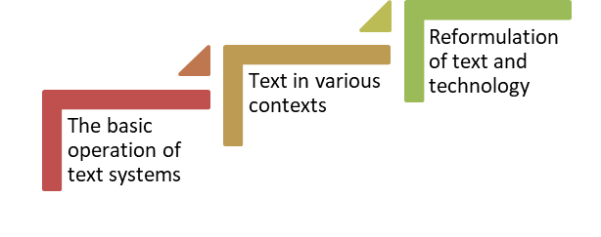
Without access to sustained and varied learning opportunities through the school system, at work and in personal life, and without opportunities to use that literacy in specific contexts, literacy development will always remain tenuous.
While people can often manage to learn the basic operation of the text system within their own networks of supports and use, acquiring more specialized literacy requires people to be active participants in various learning and earning contexts. Technology has then added another learning layer and an additional access barrier — one that is particularly noticeable because it requires physical infrastructure.
Most literacy development initiatives frame literacy as an individual ability, incorporating approaches to literacy development (e.g. a focus on phonics, vocabulary development or sequential reading levels) that are informed by the way that literacy is packaged for large-scale testing. But literacy’s reformulation by technology demonstrates that literacy is and has always been an access and opportunity concern. What is needed are useful ways to frame literacy development within this understanding.
Supporting this line of thinking is a framework that organizes digital literacy development with an aim to ensure inclusion for all citizens. Aspects of digital human capital development within the context of community adult learning centres may be useful in reframing literacy development, providing some clearly stated principles, outcomes, aims and supports.

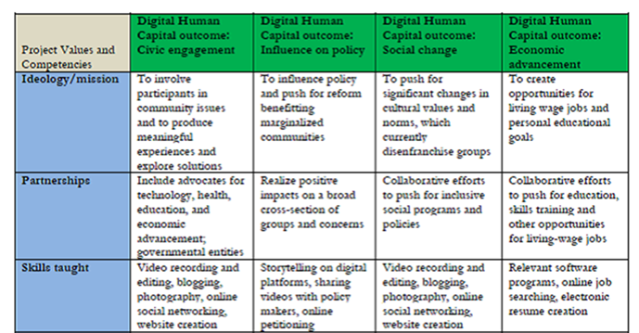

2. Socio-Economic Challenges and Access Barriers
Programs recognize and do what they can to respond to broader community
socio-economic challenges (i.e. poverty, employment shifts, lack of transportation and limited and/or costly home internet access) and individual circumstances
(i.e. disabilities and mental and physical health) that impede digital inclusion
and literacy development.

Living in Poverty
Half the students who attend community learning centres receive some form of income assistance. The other half state that they are employed (23%) or are dependent on others (27%). It’s not clear what their income levels are. However,
it is highly likely that income levels are low for most of these students too.
Program staff are acutely aware of the challenges and struggles that shape the lives of students in the program, and they do what they can to help students navigate and access services and supports.

No Affordable Access
Learners tend to choose lower-cost pay-as-you-go plans (e.g. $100 per year or $15 per month) on their phones. They often have no other devices. Their main access to unlimited Wi-Fi and other devices is through the learning centres. It’s great to have access in the program, a network co-ordinator in eastern Ontario explained, but it’s not a long-term solution.
What happens when people go home at the end of
the day? It gets lost. You’re not building capacity.
You’re making the motions of doing it but there’s no
post-training support.
A volunteer who works with learners in an urban program in western Ontario said:
They’ve got this short amount of time here. I then ask if they have something at home so they can keep working on this. Often the answer is no.
Learners know they can go to the library, explained a co-ordinator in the same program, but they are busy and their work schedules are often unpredictable. Libraries in the area have excellent services, such as free Wi-Fi, but they are limited in the amount of direct support and learning they can offer, if any, she added.
The best fit is when they can do something at home.
If they have to go out somewhere and fit that into their lives, that’s much more difficult.
Affordability becomes a larger issue in rural and remote areas that depend on satellite service, stated the network co-ordinator. Satellite access is $100 per
month in their region. Many simply can’t afford that cost. It has to be subsidized, he emphasized.
How do you get no-cost, low-cost equipment into
people’s hands?
It’s a worry and a disparity between urban and rural or remote areas, he added.

Lack of Specialized Employment Supports for Women Over 50
Four women, all in their 50s and early 60s, discussed the anxiety they feel living on a single income after recently losing their jobs. Three said they will have to work past 65 to support themselves. They face multiple challenges to finding employment, including technical skills.
They can only find part-time, lower-paid work in their community. They are also limited in the kinds of jobs they can do because of physical fatigue and chronic ailments. There simply aren’t enough decent jobs to go around, stated one participant. They discussed volunteering as an avenue to get a job, but there is a challenge if one has to pay for gas to get to the organization. Another explained
she can’t even apply for a position as a cashier, something she did in the past, since she is unfamiliar with new point-of-sale systems used to operate computerized
cash registers.
I haven’t a clue how to use a modern cash system.
Employers want to know that an applicant has this experience before hiring, she added. All were referred to the learning centre by the local employment services program to gain technical skills. However, there are few supports in place to help them transfer previous skills, find jobs that are suitable and connect directly with employers. Government supports are directed at young people, one explained, and not women over 50.

Policy Considerations
Dedicated digital literacy development programs like LBS play a key role in efforts to develop digitally inclusive communities. However, their efforts will always be limited if the people they work with do not have home internet access. In addition, their work must be considered in a broader context that includes other community partners such as libraries, employment support programs, other adult education programs, and stakeholders such as governments and businesses.
For example, the City of Portland recently developed a useful Digital Equity Action Plan (DEAP) that articulates such a broad-based and multi-stakeholder approach:
- Ensure access to affordable high-speed internet and devices for those in need.
- Provide training and support to ensure that everyone has the skills to use digital technology to enhance their quality of life.
- Empower community partners to bridge the digital divide through funding,
co-ordination, and training and staff resources.
- Create opportunities for jobs in the digital economy for underserved populations.
- Build a policy framework that supports digital equity and meaningful internet adoption, leading to better community outcomes.
Community literacy centres can be key players in providing training and support (the second element) for those who are digitally excluded, but they can’t work alone. Their efforts need to be situated within a comprehensive digital inclusion effort that also includes access, co-ordination among community partners, employment opportunities and a community-focused policy framework.

3. Learners’ Digital Literacy and
Learning Experiences
Learners have an array of digital literacy and learning experiences, repertoires and aspirations. Some have little to no experience with technology while others have extensive expertise in one area that has become obsolete or undervalued in the labour market. Others have engaged with technology intensely for a period of
time (while attending an education program, for example) and then stop using those skills once working, finding they have to relearn and update when returning to school.

Tentative Skills
All of the learners who participated in the study had some technical expertise and most said they owned a smartphone. Some educators and co-ordinators said they have occasionally worked with those who have never used a computer, usually an older adult.
A co-ordinator with nearly 20 years of experience has noted a tremendous change. In the 1990s, when most students were learning to use tech for the first time, they had a tremendous amount of fear and trepidation. That general sense of worry has nearly disappeared, she explained. An educator added that many advancements in technology in the past decade have helped to eliminate the need to teach a lot of basic tech skills, such as typing, using a mouse or saving a file in a folder. Both the co-ordinator and the educator worked in an urban program.
In general, many of the participants were comfortable using their smartphones, albeit in limited ways. Their devices were often set up by others, and their use was generally focused on a handful of apps and processes.
A co-ordinator explained that their skills are “marginalized and fragmented.”
An educator in a different program wrote the following:
Some individuals face difficulties with screen-based information absorption associated with digital technology. Personal access outside our centres may
be limited, posing a threat to successful progress.
The educator is describing a series of interrelated challenges that impact digital literacy development: tenuous print abilities, combined with new digital environments that introduce additional navigation and reading challenges, combined with irregular access opportunities.
With limited knowledge and experience, explained a tutor, their initial learning is very tenuous and tied to a particular device and application.

They aren’t sure how to connect all the pieces. One of those things I find that I’m doing is connecting those pieces. If they have to use a different device or the same device and a different word processor, they are not yet able to connect the pieces.
The same tutor said his goal is to support students to “contextualize” applications and devices. He doesn’t simply frame learning around one particular product such as Word, he explained. He helps students to understand word processing in general and then shows people how to use the application that they have access to.
People appreciate the contextualization. That’s their life. That’s what’s real to them.
He also tells learners to bring their devices to the weekly sessions so they are learning within the context of their device.
One educator noted that students aren’t always aware of the capabilities of their smartphone — that it is actually a mini computer and is quite powerful. An educator working with novice learners is finding Padlet useful. Her aim is to find tools that provide a fun and interesting introduction to technology and also support the integration of multi-modal communication. She will also integrate the use of students’ own devices to transfer a photo, for example. An educator with higher-level learners encourages her students to take photos of notes written up
for the class.

Being on the Outside
In addition, there are socio-cultural implications. A student who doesn’t have a smartphone, explained an educator, may feel:
[They aren’t] “part of the club” and part of the group of people who are technologically advanced. For some learners, it’s not making them part of the group. It’s not bonding them. They feel they don’t belong to that group of people with smartphones or who have something in their ear all the time.
A student in a different program made a similar comment. He felt he was missing out on so much related to technology before attending a literacy program.
I hate being lost on it. I want to be able to go, “I know what you’re talking about” so I won’t feel lost.

Interrelated Text and Tech Skills
Some learner participants described situations in which they need to develop interrelated text and tech skills and knowledge for particular situations. For example, one student is learning to develop a simple website and learn about online sales to support her small woodworking business. She needs to learn some general numeracy skills to support the business and track her expenses and income using a simple spreadsheet. She is also developing broader skills and knowledge of online marketing and transactions.
A few of the participating students want to enter post-secondary programs and need to address interrelated literacy, numeracy, technical, content and general readiness concerns, including the following:
- Navigating online learning management systems used by particular institutions and used in different ways by college instructors.
- Specialized subject-based knowledge and the completion of mandated prerequisite courses at the secondary level (even if a student has obtained a diploma), which may be required to apply to a particular program; access to the courses is often online.
- Some students are also working towards a GED and accessing materials online through e-Channel, where they need to manage the materials and online system independently.
An educator supporting learners to write their GED noted that her students have a tremendous amount of experience with technology. Rather than focus on finding a particular tool or technology that may be new to them, she focuses more on using technology to enhance teaching and learning work overall.
It’s less about exposing them to new digital literacy experiences and more about asking what is out there to enhance the way I’m working or the way I’m teaching. Google Classroom is an example of that.
Google Classroom also provides opportunities for students to become accustomed to using a learning management system, commonly used in secondary and post-secondary settings. The instructor said it’s an opportunity to mimic the processes they may have to use in college programs.

Use of Assistive Technologies
A student with a reading disability explained that reading on his own can be difficult. He prefers to have the text read aloud and thinks that some text-reading software would be helpful.
I find it so hard because I’m starting with the words and it’s taking the fun out of reading. If I have something read to me, that would be a benefit.
He has tried this strategy at home when reading the Bible with a set of CDs and finds it helpful. He hasn’t yet tried other assistive strategies or particular devices.

Recontextualizing Previously Developed Text and Tech Skills
Other study participants need to recontextualize previously developed text and tech skills and knowledge for new situations. For example, one student had previously worked on a Mac but now needs to learn to use a PC in order to apply for office jobs. Another said she wants to learn to use Google Docs after using Word in order to take minutes at a meeting. And another had a computer diploma, recalled an instructor, but still needed support integrating technology skills with the types of reading and writing he needed to accomplish to meet his goal.
While their text skills on their own aren’t the main concern, their transition from one technical environment to another is adding pressure. In addition, the setting in which the task will be done and the conditions of learning the new task add more pressure — potentially interfering with the text skills. The woman who wants to take minutes said she was worried about using Google Docs in front of people while taking the minutes. What if she runs into technical trouble? The woman transferring skills and knowledge from a Mac to a PC environment is feeling extraordinary pressure to find work to support herself.
Technology has added another layer of literacy understandings, explained an educator. For example, some may recognize a subject line in an email but they don’t have a broader understanding of what it represents and how to write an appropriate phrase. The concept — to summarize the content and purpose of the email text in a way that the recipient will understand — is actually very complex, she added. The perception that technology will make things easier is often
not correct.

High-Stakes Demonstrations of Test and Tech Skills
Further increasing pressure, a co-ordinator described situations in the community in which job applicants are asked to demonstrate their abilities during an interview. Word remains important in the workplace, he explained. An applicant could be asked to develop a document on the spot as part of an aptitude test.
I’m hearing that from employers, explained a support organization co-ordinator. They say they don’t care about a certificate stating someone has completed a course in MS Word. Employers are saying the applicants must demonstrate their abilities on the spot. Such a demonstration would require a comprehensive base of knowledge in order to perform under pressure.
A couple of students had very advanced technology skills. One recommended a variety of programs to protect personal security and privacy. Another is interested in game design as a career. While at the literacy centre, he then started to develop online communication and video production skills and now produces his own YouTube channel.

Dedicated Learning Centres Provide Supports Not Found Elsewhere
Students commented on their attempts to gain digital knowledge and expertise. Many had initial support from family and friends. While some said they continue to receive support, others felt more cautious about continuing to ask family and friends, sensing they may not be patient with their questions.
At home I’m different. It’s different to learn from a family member, like when you’re learning to drive a car. I’d rather be part of a class and have a teacher that can help.
Those who lived on their own explained that they generally had to learn on their own before attending a community literacy program.

Limitations at Libraries and Employment Centres
In one group interview, four of the five participants had been referred to the learning centre by a local employment agency. They all understand that the employment centre provides “basic job search” support but does not have the mandate or resources to provide more support and to teach digital skills.
They have certain things they can do but they are very limited. They will provide some assistance but don’t teach.
They then discussed their experiences in the employment centre at their
local library.
Student 1: I was just amazed at the kids who would come in with their keys. Then they’d put them in the computer and punch out their resumés. They knew exactly what they were doing. They did not need any help, and that’s what I think the staff prefers.
Student 2: Then they get us. I just sit there and
look around.
Student 3: I was afraid to ask because I already asked a
few questions ...
They also had similar feelings about receiving supports at the local library.
Student 2: You have to really know what you are
doing there.
Student 4: They’re not there at the library to teach
you computers.
In general, students are aware that they may be asking very basic questions and
feel they are imposing on people’s time in the employment centre or library.
A co-ordinator in another program noted that the students she works with are embarrassed to ask a librarian for assistance.
They value the access to a dedicated learning centre with professional staff who understand their challenges and never judge even the most basic questions.
One student said the following:
It makes me feel good that I’m learning something. I’m not as stupid as I think I am. People have to have patience, and the instructor has so much patience.
In addition, she explained, she would be nervous about attending a course in a “school setting” and prefers the small community-based learning centre, including the support she receives from other students.
You feel more relaxed and you don’t feel hesitant. If you share with other people where you’re at, they are more sympathetic and they understand.

What Do Adult Learners Say Is Important to Learn?

Safety and Security
A group of students in one program discussed the importance of learning how to protect themselves from fraud and manipulation when online. The conversation started when one student recalled the experiences of another student, an older woman who was learning to use a computer for the first time.
I feel for that woman. She has absolutely no skill level. The first thing they are teaching her is how to log on and off, but what she also needed to learn is about viruses and nefarious sites.
People need to learn how not to be a victim of fraudulent and nefarious programs. All of a sudden, everything you’ve ever worked for is going to someone. They have armies of people trying to steal our information.
Another student started to share his knowledge about various add-ons and applications he has learned to use to protect his computer and online activity. People need to protect against hacking, he explained, recommending NoScript, an extension to avoid pop-up ads and malicious viruses. He also suggested that people need to learn how to clear their cache regularly.
Both then discussed how they have learned to deal with viruses and accumulated malware. One mentioned the use of a FixMeStick. The other discussed how to find a trustworthy technician when nothing else seems to work.
A third student then explained that he never used to worry about someone taking his information until the day he became the victim of debit card theft while purchasing gas. He had $1,500 stolen, which was returned to him by his bank, but he is now much more cautious.
No one currently uses learning apps on their smartphones. One said he often looks at YouTube videos to learn something. Others also use YouTube to do repair and maintenance work on their cars. Phones are mostly used for texting and talking along with maps, GPS and quick Google searches. One student said he occasionally downloads manuals and then prints and reads the material. None read extensively on their phones, preferring books and paper sources.
Educators’ Perspectives
Students commonly use Facebook and YouTube videos. These are mechanisms that “reward people and keep learners hooked,” said an educator. They may also have a very narrow focus and limited repertoire — a limited set of “go-to apps” or communication modes such as texting and emailing.
They have these tools they resort to because it solves a very immediate problem for them.
They learn to use a few very specific tools.
Another educator added:
They don’t get the landscape of the digital world when it comes to privacy, safety and security. Then it is misleading when they say “I can use Google or Facebook” when they don’t know how to use it appropriately, effectively and securely.

They then discussed the usefulness of learning to do more precise searches using AND, OR and quotation marks. Two agreed this would be very useful to learn. People also need to be wary when spending too much time with technology, particularly when gaming, added a younger student. It’s also important to learn about heathy tech use and to recognize when teens and young adults may be running into problems.
Students in this program had some very clear ideas about what they would like to learn in relation to technology in their lives. The two educators from another program have observed these learning interests in their own programs with different learners. Neither program appeared to have a course, learning group or workshop dedicated to the topic.

Theoretical Considerations
Digital literacy development is dynamic and contextualized. Skills are not static and readily transferable across contexts. And learning is motivated by interests and practical purposes. All of this became apparent as learners discussed their engagement with various technologies and reasons for being in the program.
A recently produced description of digital skill development across the population is useful. It is one of the few attempts available that articulates both the contextual nature of skill development and its fluid and dynamic nature.
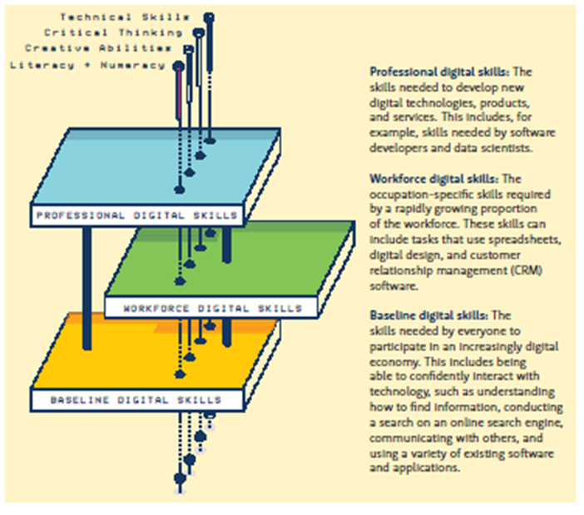
Three broad areas of skill development — everyday or “baseline” skills, workforce skills and professional skills — establish very different contexts, circumstances and purposes for learning.
- Baseline or everyday skills are those that people use in their lives to make transactions and access services.
- Workforce skills are occupation-specific and could be further contextualized. For example, educators are developing repertoires of skills and knowledge to support pedagogy, and learners could be developing very different sets of workforce skills to support specific jobs.
- Professional digital skills are those used to develop “new digital technologies, products and services.” For example, one student in the study was interested in pursuing a career in game design and was honing professional skills to produce videos and content on his own YouTube channel.
Within each broad area are more specific sets of skills and abilities — technical, critical, creative and literacy/numeracy — that are shaped by the various contexts in which they will be put to use. Such a conceptualization can be used to organize the way we think about digital skill development within LBS programs to support both the learners and the educators.

4. Organizational and Instructional Approaches
The six programs develop both organizational and instructional approaches of digital inclusion that suit their contexts. They are supported by caring learning relationships and provide numerous examples of responsive and meaningful programming. Their choices are shaped by learners, overall program operation, technical requirements, staffing requirements, access to resources and expertise, and access to content. More recent interest in what are called short or modular courses (also referred to as boutique courses) has been a response, in part, to the funder’s accountability measures.

Semester/Year-Long Classes and Learning Groups
Two of the six programs organize instruction in group sessions that run over the course of an academic year or a semester. They are the two largest programs with enough students and staff to run regularly scheduled sessions for different groups of adult learners for a few hours each day.
In one of the larger programs, digital learning is integrated into the overall schedule complemented by cross-curricular activities and team teaching. Students were not divided by level, and each educator worked with students at multiple levels, presenting the same topic but adjusting the difficulty and complexity of related activities according to the students’ abilities and goals.
In another program, students were divided into three groups based on their abilities: (1) beginning learners who had very limited text skills, (2) middle-level learners and (3) higher-level learners who were preparing to write their GED. In this model, digital skills development is integrated into the content and learning activities of a specific class or learning group by each educator, who has a great deal of autonomy.

Short/Modular Courses with Pre-Developed Content
Five of the six programs also offer short (modular) courses, usually running for six to eight weeks for a few hours each week. All offer a course on computer basics in a Windows environment including MS Word. Some also offer employment-related courses and other technology courses, and one program is developing reading- and writing-focused courses that address a particular topic or skill. The table below lists the courses under development or currently offered across the five programs.
Learning Domain | Topics
Technology | Computer Basics  Northstar Certification  Advanced Topics (Excel, Word, PowerPoint)  Internet Searches and Security  Using Tablets and iPads  Google Suite  Social Media Use and Digital Portfolios
Employment | Workplace Hazardous Materials Information System (WHMIS)  Smart Serve  Safe Food Handling  Soft Skills Solutions  Customer Service/Service Excellence  Point-of-Sale Systems and Customer Service
Academic | Essay Writing
Household | Reading for Health  Financial Math
Transformative Knowledge | Exploring My Community (integration of history, geography and civics)  Where Do I Come From? (exploring community and family history)  Motivational Learning and Personal Development  Social Justice and Equity Topics  Management for Women

Many of the technology and employment courses provide a certification that students can use during an employment search. The certificates are valued by the students and employers, commented a co-ordinator.
If you give them that proof of learning, it goes a long way.
The development of numerous short courses focused on technology is a more recent activity, explained each of the five program co-ordinators currently offering the courses. Previously, accountability measures could not be used to report on student success and completion rates using technology-related courses and content on their own. In other words, technology had to be integrated into other courses, content and topics. With the release of the restriction, programs have moved quickly to develop new courses. The courses serve several important purposes:
- An outreach mechanism to inform communities about the learning centres.
- A way to attract new learners and potentially have learners participate in other courses and programs.
- A way to meet increased targets.
- A way to comply with targets and reporting in an efficient manner,
which can allow many programs to continue working with more
long-term learners.
- A way to maximize limited staffing and have volunteers take on
additional roles.

Technology Courses
Programs predominantly use open-source content to develop technology-related courses, which they then supplement, remix and re-present to learners in various ways. They make these changes to accommodate the various skills and interests of the learners and the teaching formats that they will use.
As an example, the computer-basics content is primarily composed of screenshots with support instructions, labels and very clear step-by-step instructions assuming the learner is a complete beginner. Two programs have packaged the content as PDFs that can be accessed in print or on the screen, developing a highly detailed and visual resource. “It’s a good starter. It’s also great that we have it printed,” explained an educator.
Although content is readily available on the site GCFLearnFree.org, students have to have some technical skills, which they may not have, simply to navigate the site, such as opening two screens or following a link to complete an activity. Having the content in print along with guided directions from the instructors supports beginners. Once students have some experience, she added, GCFLearnFree.org is a “great resource.” Their approach “really appeals to all types of learners.”
You have the hands-on work. You have the auditory and the visuals, the written information and the pictures.
One challenge with this approach, a couple of participants explained, is the need to update content regularly when applications and platforms are updated in order to ensure what the student sees on the screen is the same as the support materials. It’s very challenging to create content and additional materials without extra funding, commented an educator. Another suggested that small grants to develop curriculum and content would be useful.

One-to-One/Individual Instruction and Support
Two of the six programs also offer some regularly scheduled one-to-one support, and all provide individualized, on-demand support as needed.
One of the technology-related questions and requests that students have is related to the use of their own devices. Two of the programs readily provide any kind of support they can, including troubleshooting the operation of the device and particular applications. However, two other programs questioned whether it was beyond their role to provide ongoing technical support. It is also an area in which they have limited expertise, they added.

Organizing Pedagogies
Across the six programs, educators make use of a variety of instructional approaches, materials and technologies within each of the three organizational models (i.e. year-long or semester-long regularly scheduled sessions, short courses and one-to-one). Choices are made based on a combination of interrelated factors, including the following:
- The size of the program.
- Whether courses or classes have continuous intake.
- Learners’ interests, goals and skill levels.
- The educator’s familiarity and comfort with various approaches
and pedagogies.
- Access to materials, resources and others to discuss new approaches.
- Time to try new ideas and approaches.
- A program’s philosophy of learning, their role in the community and broader social and political issues.
In general, two broad approaches can be described. One is a transformational and contextualized approach that integrates digital skill development within meaningful contexts, and aims to support students in developing new ways of knowing, being and seeing themselves through particular learning projects and activities.
Another is a preservation and decontextualized approach that isolates discrete language, mathematical and digital skills to focus on their acquisition, and adheres to reproducing the text and processes on the page (or screen) rather than developing and producing something new.
Examples of both approaches were observed across the six programs, and both are of value. It is not our intent to describe the extent to which either approach was in use but to simply introduce the approaches and provide some examples from the programs, paying particular attention to the way technology is integrated.

Transformational and Contextualized Approaches
Examples of transformational and contextualized approaches include the following:
- Experiential and contextualized learning planned around particular events and ongoing opportunities (such as field trips, mock trials, mini-conferences, and operating a lunch/snack counter), all of which support authentic language, literacy, numeracy and digital development.
- Social enterprise opportunities to directly support adult learners’ lives and employment opportunities, which can also serve as an opportunity to support authentic language, literacy, numeracy and digital development.
- Digital storytelling designed to integrate personal narrative, agency and digital media.
- Social justice and equity courses integrating critical questioning, discussion, collaboration and consensus to explore complex issues and topics such as racism, systemic inequities, sexism and misogyny, ableism and classism; activities are dynamic, often integrating digital media, the arts, writing, research and activism projects.
Google Docs Strategy
An instructor explained how and why she uses
Google Docs.
To avoid lost files. Students are no longer worried about not saving and losing or misplacing a file.
To support collaboration and group work. When working on paper, students could have the paper with them and then be away, creating a disruption. Now the instructor has some control over all of the disparate pieces students are working on.
To support scaffolding, allowing her to develop partial components like a table or sentence starter that students can then use and further develop.
To model certain formats or structures. She will supply or develop an example that students can then use when developing their own. “It’s like a hands-on-hands” approach, she explained. She will also make corrections and revisions to a piece of writing simultaneously with the student, adding some rationale and further explanation.

A co-ordinator and educator who is part of a highly integrated and transformational program shared her insights. She explained that they strive to ensure they don’t duplicate the structures in formal education systems that can be oppressive and restrictive. One example is the way the program views assessment.
Programs often work with the idea that they have to divide people by skill level and box people in, she explained. Although it is important to understand skill development as part of a comprehensive assessment process, skill divisions do not have to be used in all aspects of the program, such as organizing learning groups. People with different levels of abilities in numeracy or literacy can communicate and work together on a project. They can participate in a discussion and can then take on a variety of tasks according to their abilities.
Once people are honoured, then they begin to excel in areas that the assessment doesn’t reflect. People come with a lot of layers in terms of their mental situation, their emotional situation, their physical. That’s not stuff that comes out in an assessment.

Preservation and Decontextualized Approach
In addition, all programs also include approaches focused on activities that preserve and reproduce the decontextualized text (and numerical operations) on the page and screen. This means that learners engage with pre-set curricula (online or in workbooks) often focused on discrete aspects of literacy (such as reading comprehension) or numeracy (such as whole numbers). The approach is rooted in the notion of remedial learning. Activities that are identified through testing are designed to be learned sequentially, gradually becoming more difficult so that a basis of skill is strengthened in order to support other learning activities.
Examples include the following:
- Use of the online reading comprehension program Read Theory, a series of graded reading passages accompanied by questions focused on vocabulary development, comprehension and written responses to questions designed to promote analytical thinking and logic.
- Use of a variety of sites targeting specific domains of skill development such as vocabulary (using Freerice.com) or grammar (using The Purdue Online Writing Lab).
- Workbooks focused on broader domains of reading and math.
When educators must respond to individual learners with varying interests, goals and abilities, packaged content (whether in a workbook or online) helps them respond to a complex instructional environment. The materials provide a clearly articulated learning path, are readily accessible within and outside the program, and are aligned with the school system, particularly at the elementary level.
Students also respond positively to the approach. In one program, students said they appreciated the routine, knowing exactly what they had done and what they needed to accomplish. Instructors facilitated this process by creating accompanying tracking sheets containing particular lessons and skill sets to complete based on the students’ assessment results.
Students in another program had participated in a research study designed to support the development of an online reading development program. The participants spoke very positively about their experience, appreciating the feedback and sense of accomplishment that the program provided.
However, explained an educator, no one can be expected to simply sit in front of an online program, no matter how well it’s designed, and learn in a comprehensive way. “The challenge is that generally for literacy learners, you need instructor support,” she explained.
Students can press buttons and get scores and think they are doing just fine, with very little sense of what it means to reflect on content. Students need to understand what they are trying to do when using these tools.
A different co-ordinator recalled using AlphaRoute, an online skill development program in use in the late 1990s and early 2000s that was designed specifically for Ontario adults. She explained that the program was very useful, as it supplemented her role, allowed students to work within and outside the program, and freed up some of her time so she could develop some group learning activities to respond to the changing interests and abilities of learners.
Online Discovery Strategy Using Searches
An instructor explained how he designed an activity on internet searches using a discovery method rather than a prescriptive method.
Search concepts, use of proper terms and labels aren’t explained upfront. Instead, students are given minimal direction and try out various searches to see what will happen. They then explain what they discover using their own words and understandings.
For example, the students all enter a specific search term and then describe what they see on their screens.
The instructor directs their attention to the search results, guiding them to look closer. He asks them to identify what they see. They then discuss common ways results are manipulated, such as presenting paid hits first in a list.
Students then try out additional searches using filters such as AND, OR and quotation marks. They describe how each filter makes a difference to the search results. They then spend time using various search terms and filters and comparing results with each other.
Finally, they try their own independent searches to support a particular project or interest.

Maintaining Engagement and Extending their Reach with
Virtual Access
Two of the six programs are actively engaged in new virtual learning projects to help them extend their reach and maintain learning engagement and connection with their learners while they are enrolled in the program. Using conferencing software, the programs want to provide live access to instructors and peers when face-to-face classes and workshops are taking place. The need is responding to those learners who want to participate in face-to-face programs but have access barriers related to transportation, child care, and health. It’s a way to provide continued engagement for those who have traditionally left a program without completing their goal.
The model is different from the current online learning model used by e-Channel, as it provides fully synchronous access, allows learners to move between face-to-face and virtual connections as needed, allows the program to change and develop curricula that is responsive to each learner group, and could lower the number of participants who stop out of a program before completing a course or meeting
their goals.
Both programs are pursuing alternative sources of funding to develop their virtual classes and workshops. One co-ordinator explained the challenge she had when attempting to secure core funding through the tech refresh initiative. The Ontario Ministry of Training Colleges and Universities didn’t understand the difference between a remote access model and the online learning model used by e-Channel, she explained. “It was frustrating.”

Learning on Paper or on the Screen?
During two different group interviews, students discussed their preferences for learning with paper and online. In general, their preferences are based on the context and sometimes related to personal learning choices or needs to accommodate a learning disability.
One important aspect of learning online is access to their work if they have to miss a class or session. They did share some frustrations related to unexpected mixing of paper and online activities within a particular learning context or activity. One student explained that she doesn’t like switching back and forth between paper and online activities and would simply like to do one or the other in her regular class. When there is a mixture, make sure there are “routines,” she suggested. In addition, students in one group said they would prefer to complete all milestones (assessments that all LBS students are required to complete) online and not do half on paper and half online.
In the other group, students participate in an on-site work experience program, providing many opportunities for authentic activity and contextualized skill development. For example, they are learning to use a point-of-sale system as they run a small snack and lunch counter. However, they recognized some of their tasks are designed to teach basic skills and not necessarily designed to operate the lunch counter. These activities are often paper-based. It’s done so we “use our noggins more,” said one student. Another then added, “It’s old school.”
Students in both groups stressed the importance of learning within the program the same way that they need to learn and complete activities outside the program, whether their learning supports their work or academic goals.
A student wondered if their paper-based activities, designed to develop reading skills and find information online, actually helped her. They didn’t seem to relate to anything, she commented.
We’re not doing anything that constructive with what we are doing other than answer questions. We can do that online at home. What can we do that is more constructive in class?
It seems students are wary of learning skills, whether technology- or reading-related, simply for the sake of acquiring that skill and not applying that skill to complete a meaningful and authentic project or activity.
One educator commented that he avoids teaching “tech for tech’s sake.” For example, he elaborated, tech for tech’s sake would include teaching specific terms that really aren’t important or a certain way of navigating the screen that is program-specific. By extension, teaching text for text’s sake is also something to avoid, based on the above quotation from a student.

Considerations and Critical Questions
During one of the group interviews, educators raised some compelling issues and questions without easy answers. Their discussions may help other educators think about similar questions and perhaps come up with their own responses. An educator explained the importance of finding the time to explore difficult questions. “We get wrapped up in the immediacy of the task and don’t ask the different questions,” she commented.
- Should they be teaching technology simply because it’s used in a certain workplace? If those decisions are made, what happens when the technology becomes outdated?
- Is a learner’s request to learn Microsoft (MS) Office truly related to employment or could it be an indicator of something else?
Learners may come in saying that want to use Office because to them, that is
an indicator of technological knowledge or perhaps they think it is a key to a better job.
Someone may say they want to work in an office, but what they really
mean is that they don’t want to continue doing the job they have and would
like something that is less physically demanding and perhaps more stable
and predictable.
It’s important to work with that and work beyond that initial statement to better understand what the learner may need to support his or her goal, which may not even be related to working in an environment that uses MS Office.
- However, the certification related to MS Office or Word is highly valued on
its own; it’s an indicator of accomplishment that is recognized, and it signals belonging. Aren’t these also important reasons for teaching a stand-alone application?
- Perhaps by integrating the application within the context of people’s day-to-day interests and activities, they can address both meaningful and relevant literacy/numeracy aspects and a sense of accomplishment and belonging that may accompany a recognized certification.
- Educators must ask, What are we implicated in when we use Google products?
By choosing to use Google Classroom, for example, an educator explained that she is able to monitor students’ work more closely and communicate with students outside of the program. Their data is also accessible by Google. Am I preparing them to unquestioningly and unknowingly accept other kinds of monitoring and surveillance?
I know this is the slim edge of the wedge for what is happening in employment. We are preparing them for a total surveillance state in the workplace, where employers can surveil every aspect of what an employee is doing, every keystroke.
Additional compelling questions were also raised in other conversations:
- Where do we draw a line between providing general learning assistance and providing technical assistance to students with regard to their personal devices?
- How do we better integrate literacy and numeracy development with technology to get past the workbook model of learning?

Pedagogical Considerations
Efforts to support educators also need to be considered within a broader pedagogical context related to adult learning, literacy and language development. The SAMR model can be used by educators to help them develop their practice and reflect on the way they can use technology to enhance and even transform their teaching practice.
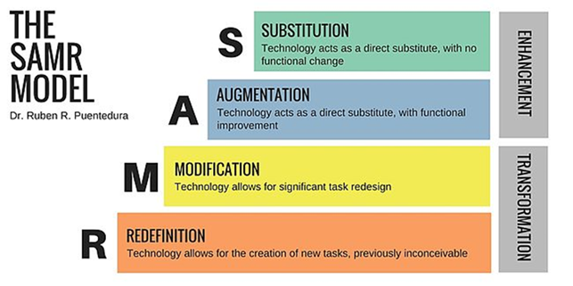

Substitution references choices made in which technology tools are used in place of traditional paper-based activities without any substantial pedagogical change
(e.g. rather than use a textbook, students go online to gather, compile and perhaps synthesize similar information).
Augmentation refers to technology choices that lead to some enhancements of current practice particularly related to access to material. However, what students then do with the materials or content remains very similar to traditional paper-based activities. For example, students may access short stories or novels using ebooks, perhaps providing more choice, but they then also continue to interact with the text and each other in similar ways — perhaps producing a book report or responding to comprehension questions.
The difference between augmentation and modification is the extent to which a teacher modifies what they would normally do in their practice using a particular technology. For example, when student are accessing ebooks, they could then form discussion groups that run similarly to a book club to interact with the text in a different way. The online choice is extended to the classroom, allowing students to simultaneously be engaged in reading a variety of texts based on their interests. Technology, such as self-publishing and digital storytelling, could also be introduced to support the development of student publishing projects, helping to completely transform traditional engagements with texts in which the student only responds to what is read. With technology, the student can also be a creator and producer of published text in a process of redefinition, allowing for the “creation of new tasks.”

5. Professional Practices and
Curriculum Development
Without a comprehensive professional development strategy to support pedagogical planning and decisions that include technology, educators who participated in the study primarily draw on their personal repertoires of
technical expertise and share resources to support professional practices and develop curricula.
Currently, LBS programs have a non-standard approach to initial training requirements and ongoing professional development (PD) that varies across the main sectors (i.e. community, college and school board) and streams (i.e. deaf, native literacy and francophone). In the past, the funder has directly supported only ad hoc training when introducing new accountability and reporting systems. One co-ordinator explained:
PD is always a big issue. Going for PD means shutting down the classes, which we don’t want to do. It means one of us goes, and then we use a train-the-trainer model, which doesn’t always work. Sometimes you need everyone sitting in on the same training so that collaboration in learning leads to collaboration in working. We know learning in isolation doesn’t always work for our students, and it doesn’t always work for us either.

Professional Development Differences
Professional development access and opportunities varied across the six programs based on their location, size and access to additional funding and resources.
- The two larger programs were able to build their own in-house opportunities by providing regularly scheduled paid non-teaching time that could be used in a variety of ways (e.g. curriculum development, sharing insights and expertise, trying new technologies and getting support).
- A smaller program that was part of a national support agency was able to supplement LBS funding and provide numerous training and PD opportunities for their LBS educators, usually related to employment readiness to support learners.
- A smaller independent program in the eastern region of the province had access to a regional conference planned every two years, established some working relationships with other programs to share expertise and curricula, and plans to use LinkedIn to support program management and technical skill development.
- A similarly sized independent program in western Ontario, however, did not have access to a regional conference.
- For a small, remote northern program, there were no regularly scheduled in-program or regional opportunities; however, as a small program, they could collaborate and share expertise when required.
A co-ordinator in a larger program explained that they have intentionally pursued a process of questioning what they do and why.
We have made it part of our project to think about our work and ask questions. Every week we set aside an hour. It’s a cultivated and deliberate time.
To innovate takes time, the co-ordinator added. Small insights are gained incrementally by talking and sharing with others, followed by time to experiment and follow up with others about how things worked. She acknowledged that their program is fortunate to be able to do this work. “When would others be able to sit down and try new things using paid time?” she wondered.
One co-ordinator discussed the importance of compensating staff for their time when supporting the development of new initiatives. All instructors work full time and have paid preparation and administrative time built into their schedules, she explained. “Their time is always compensated.” In addition, new initiatives may be supplemented with additional compensation if needed. Preparation time can be used for both day-to-day program development and new projects and courses.
The learning centre develops its own content to ensure a broader social justice, equity and community development perspective that may not be found in traditional content.
Staff work together as a team, she explained, particularly when they support projects such as a mock trial, digital storytelling, entrepreneurship and slam poetry. “It’s a very collaborative work environment and not siloed.” The paid time and equitable work conditions have helped the program build its innovative and dynamic approach.
It takes energy, a vision, supportive leadership and energetic staff who want to try something new, the co-ordinator explained. In addition, resources, outreach, buy-in from people and occasional seed money may be needed to develop and pilot a new program.

Content Access Challenges
Access to content is an issue, particularly for smaller programs and programs that work with learners who have more tenuous skills. Content is a combination of open-source and/or purchased materials that are then reassembled and supplemented by the instructors for individuals or groups. Content is neither prescribed nor regularly developed and supported by the funder, although funding has been sporadically available to develop learning materials.
It’s an ongoing challenge, explained an educator in one program. “We’re constantly trying to reinvent the wheel.” She explained that content is shared with each other within the program or they access existing content online, spending a great deal of personal time searching for appropriate materials.
A co-ordinator from another program said:
Sometimes it’s overwhelming. Technology brings too much to us.
One co-ordinator wondered why they can’t have more access to content developed by e-Channel programs once their learners are registered. Instructors would also like to access the content so they can better support their learners.
Meeting targets and becoming protective of content is also an issue between programs, noted a co-ordinator.
Now people aren’t even sharing. The competition is counter-productive. It’s become quite ugly.
They worry that someone else will attract more students and their program will be in jeopardy and get shut down, she explained.
A previous source for free content was the National Adult Literacy Database (NALD and later Copian) but the on-site repository of materials lost its funding in 2014. Although some materials can still be accessed, links are often broken and materials aren’t being updated, commented an educator.
The field doesn’t have a sustained means to develop and access content.
There’s no new training and there’s no access to content and resources, explained
a co-ordinator. There is also no communication.
No one knows what’s going on — literally. We’re left to figure out everything ourselves.
Another challenge is accessing content for adult readers that isn’t childish if they are reading at an elementary school level. “They don’t need rewards,” said an instructor in another program.
An educator summarized what guides her when evaluating the usefulness
of resources:
What’s working out there? What’s good content?
What’s low-cost and available? How best to convey the information to learners?
Programs are also devising their own solutions. Two programs described how they have exchanged content with other programs in their region.
One program has devised a collaborative approach over the years. All resources belong to the organization, which were developed using paid time. New instructors have a set of resources to draw on, which they then update or enhance. The program has also drawn on the support of summer students to build their resources. Another program regularly accesses some content from ABC Life Literacy Canada, a national non-profit organization supporting adult literacy development, including financial literacy, health literacy and workplace literacy.
Considerations
Educators and co-ordinators also commented on what is needed to make professional development (PD) work better.
- Send all staff to PD and stop relying on a “train-the-trainer” approach, which never works well, commented one co-ordinator.
- Ensure there is some regular time built into people’s schedules to discuss pedagogy and attempts to try new tools, explained another co-ordinator.
- Content development combined with professional development that integrates tech, literacy and numeracy would be useful, commented an educator.
- Have a big-picture understanding of technology choices and strategies so that tech is used as a tool in a broader pedagogical approach, commented two educators.
If I’m teaching division, I would use every tool that I have to make that learner feel comfortable with division, and if it didn’t work today, I would use something on the internet tomorrow or I would use paper and pen and just cut up parts. I think for me,
it’s not something that’s outside and separate from my approach. It’s very much a part of it. It’s another tool in my toolbox to help the learner.
- Build a sustainable approach that considers the dynamic nature of technology and helps educators adapt to change.
- Combine professional development with content development to support educators in becoming adept digital curators.
Digital curation is the sifting and aggregation of internet and other digital resources into a manageable collection of what teachers and students find relevant, personalized and dynamic. It incorporates the vibrancy of components of the internet and provides a repository that is easily accessible and usable.
Curating open-source resources is a fundamental teaching competency, argue the cited authors, for teachers engaged in literacy development in all its forms (digital, media and information) at all levels of education (K-12, higher education and basic education). Complex decisions related to the types of tools, learning purposes, learner and instructor comfort with various tools and literacy aims must be considered.

6. Programs Address Policy and Program
Operation Concerns
Participants in this study discussed a series of issues directly related to the design of the LBS accountability system that continue to shape their work and direct decision-making away from learning and learners and towards compliance. They have also devised numerous reporting and documentation strategies, ways to supplement their work and even small acts of defiance to maintain the integrity of their programs. These efforts take time away from program development and supporting learners both directly and indirectly.

Reporting and Documentation Strategies
Numerous strategies are in place help co-ordinators and educators to streamline reporting and documentation requirements so that the least amount of time is spent on accountability processes that have little direct connection to actual program activity. One co-ordinator said she is often duplicating and triplicating information.
For every hour that someone is a learner, we probably do an hour and a half of paperwork. It’s ridiculous.
She is also worried about threats of actionable letters that are sent if the program is not compliant. If a program gets three letters, their funding gets reduced.
I know of one program that got cut by 60% because they weren’t meeting their targets.
In general, the two larger programs limit the administrative work done by instructors and have staff dedicated to doing the mandatory documentation work required by the funder. Smaller programs are eroding the hours dedicated to students in order to find time in their schedules to complete administrative work.
Learning the new reporting, data collection and assessment system “was so stressful,” said a co-ordinator. They had to find a way to increase staff hours to full time to take on the additional responsibilities. “There was no way we were going to keep up with this.” Now there are enough hours in the day, and these are paid full-time hours. Although they can keep up with the workload, they question the usefulness of many aspects of the reporting and administrative work. They continue to produce duplicate paper and digital copies. “Doing one or the other would save a lot of time and frustration,” added the co-ordinator.

In another program, the co-ordinator described her initial experience with the reporting and accountability system when it was initially introduced:
It was very stressful. Having been in the position of working a million hours and running into personal trouble as a result, I refuse to do that again. That means the data for [one satellite location] just isn’t getting done as regularly. Something had to give.
All programs have found ways to limit the time they spend on mandatory accountability work, such as creating learner plan templates and pre-selecting milestones to align with particular short courses.
One co-ordinator explained that they try to handle the student file only once while the learner is in the program. “The administrivia is so heavy,” and it’s only a six-week program, she explained. In response, registration, assessment, learning plans, milestone information and initial exit are compiled and inputted in one session. We have to “work smart not hard,” said an instructor. The co-ordinator added:
Everyone is starting to see where we can save a bit of time and get back to the reasons that we decided to work in literacy in the first place.

Supplementing
Programs also described how they dedicate additional time and resources to supplementing or developing new frameworks and progress indicators that are pedagogically useful and provide relevant information about transitions.
One co-ordinator acknowledged that the Ontario Adult Literacy Curriculum Framework (OALCF) is simply a compliance tool and isn’t being used as a learning development tool.
We are teaching to the milestones to get our little check marks. I don’t think it was intended to work that way.
Even in an ideal world, with all the time and prep,
the milestones are limited in how they represent
learning progress.
Rather than refer to the OALCF framework and assessment system, participating instructors and co-ordinators said they do the following:
- Connect directly with transition partners to discuss transition readiness.
- Devise their own sets of assessments such as rubrics, checklists and demonstration activities to indicate transition readiness and
skills acquisition.
- Separately fund their own projects and activities to demonstrate interrelated and multi-modal skill, knowledge and concept development.
- Keep learners off the books to avoid subjecting some adult learners to the OALCF assessment system and ensure they are inclusive.
Another aspect being supplemented by one program is access to training that is needed to complete the reporting and accountability requirements. That includes Employment Ontario Information System – Case Management System
(EOIS-CaMS) training support for new staff. The online training module no longer works, she explained. She has travelled to programs on her own time to offer some assistance to people in her region. However, she was then chastised by a
ministry official.
They aren’t meeting targets because they don’t know how to enter their data properly, so I’m helping them. Then the ministry had the nerve to tell me that I better not be double-dipping and getting paid by my centre and them at the same time. I volunteer this time. But can you imagine? Here I am trying to help them.

Using Short Courses to Maintain Inclusive Programming
and Meet Targets
Annual targets have recently increased, which has put pressure on staff to find new learners to meet those targets. Learners who need more than one year in the program can only be counted once towards the target. A key concern is finding a way to continue to support very beginning readers and writers who progress slowly. These are the learners who are considered the foundation of the program and community-based literacy, explained a co-ordinator. “They take longer to learn
and reach the milestones, and [the ministry] doesn’t understand this,” said an instructor. Another added, “Our core learners may take three to five, even
six years.”
We can’t lose sight of why we are here in the first place. All of these things are great ... and we still want to work with our traditional learner group.... It’s about finding ways to continue to do this.... We need to broaden our scope.

The people to attract to the program to help broaden the scope are those with “slices of skill deficits” perhaps in computers or in need of some soft skills or other kinds of technology skills, like a point-of-sale system, the co-ordinator explained. They aren’t necessarily being held back by text on the page across all situations but by the way text (print and numbers) is used within the context of technology or within the context of effective communication and interactions on the job.
However, the people who need access to technology the most are those with the greatest challenges who also have the least access to the program, explained
an instructor.
It’s a perennial problem; people in poverty have the least access to resources that can lift them out of poverty.
They need the most teaching support. One can’t simply sit them in front of a computer, explained a co-ordinator. They can’t access these programs independently and need someone to support with both the online navigation
and the actual learning content.
We need more time with this group but aren’t incentivized to work with them, particularly if they need to engage with the program for more than one year.

Keeping Learners off the Books
In response to both the administrative demands and the increase in targets, participants explained that they sometimes work with learners without registering them into the system. They make this choice even though they are under pressure to increase their learner numbers.
Programs are not only judged on the basis of total learners but their performance is also judged according to learner “suitability” targets. These targets favour a working-age adult, which means that older adults and particularly those who do not have an employment goal do not contribute to a program’s performance measure. In other words, there is an indirect disincentive to work with this group.
For example, explained one co-ordinator, an increasing number of seniors are living in the area as young people move away and new seniors move into the area. They currently work with learners off the books and outside of the regular class time, often covering time with different funding streams. “I absolutely feel this is a really important thing to do,” added the program co-ordinator. In the previous accountability system, they counted all of their senior learners and had established partnerships with local libraries.
They are also working with young students who often have learning challenges
and negative school experiences. In this example, the student was not registered
in the system because the co-ordinator was reluctant to have him complete a milestone assessment.
I’m not going to make him do a milestone. I’m not putting him through that. It’s like pulling teeth to get him through [the credit].
In other instances, a learner may want to engage with a program for a very short period of time in order to request assistance with a particular concern, explained another co-ordinator. It’s not worth the effort to officially register the learner, explained a co-ordinator.
We help them, but it’s way too much effort to set them up in the program so we don’t bother. The system doesn’t allow for all of the help we give when it is too short to include a milestone and culminating task but still gives the learner skills that really are important.
Based on the ministry’s perception, explained a co-ordinator, learners should be in the program for six to 12 weeks.
That’s ridiculous beyond anything. We have learners who can learn something in 10 minutes and we have ones who will be here for 10 years.
Other funding streams “are absolutely critical” to maintain the program and continue to be inclusive in their communities, emphasized a co-ordinator.

Transition Barriers and the OALCF
Indicators of transition readiness that rely primarily on the OALCF are too vague to be useful with other education providers outside of LBS and within, explained some participants. One co-ordinator stated:
The ministry wants us to do assessment but they haven’t actually given us one. They used to tell us what these levels mean, but they don’t mean anything. It’s all subjective.
It would be useful to have a description of digital literacy development that connects with textual (and numerical) development and the people who attend programs. “I don’t know how much you can apply this OALCF in the classroom,” commented an educator.
This has a direct impact on the opportunities available to support digital skill development, including e-Channel. To make up for the inadequacy of the OALCF, programs devise workarounds and alternatives, including the ongoing use of common assessment protocols and tools developed before 2012, when LBS was integrated into Ontario’s employment services system.

e-Channel
In general, educators and co-ordinators would like to develop closer working relationships with e-Channel providers. Currently, the providers operate similarly to a program rather than a complementary and collaborative support. That means there are barriers, unnecessary duplication and some access issues.
One co-ordinator explained her frustration with making referrals to online learning programs offered through e-Channel. She wants an indication of course difficulty and any prerequisites so she is confident that students will be able to handle the materials. Although the provider she normally uses cross-references course content to the OALCF levels and specific task groups, the information isn’t useful to her.
I’m excited about this opportunity to access online learning. I know it’s not going to replace what we do so I’m not threatened by it. But I haven’t referred people because of this issue. I’m not setting my learners up for failure. I’m not going to do it.
On-site programs also like to use e-Channel to supplement their already stretched instructional capacity, explained a network co-ordinator. If there is not enough funding to add another instructor, they refer to e-Channel to supplement their instructional capacity on-site.
A more precise way to gauge readiness, such as reading levels and an indication of specific skills in the course, would be much more useful.
They should be providing a screening tool. What do my leaners need to know to be ready to take an online course? Why not have a simple screening or readiness tool that all can use to support a transition to online learning?
In addition to the lack of information to help gauge learning readiness, educators are also concerned about the additional administrative work a student must complete to access e-Channel programs. The learner will have to complete a second lengthy registration form and receive follow-up calls from both the on-site literacy program and the e-Channel program.
Accessing e-Channel can be a challenge, even if the instructors feel the individual is prepared to work independently online. One challenge with accessing the content, noted an educator, is that their content utilizes Adobe Flash, which Google products such as Chromebooks don’t directly support. In addition, most students only have smartphones, making it challenging to access online e-learning content outside the program.
It can also be challenging accessing online mentors and supports. “They actually don’t talk to anyone. There is hardly any contact.”
There has to be a better way. It’s not right. Why can’t
e-Channel refer back to programs in communities for extra support once they sign up their students?
Whom can you talk to that will actually listen to you to say that this needs to change?

Milestones in Short Courses
While all LBS programs have devised ways to integrate the milestones (an assessment designed to show progress and abilities gained as a result of attending
a program), programs that are currently offering short courses have had to be particularly thoughtful when courses are only six to eight weeks long. In general, choices are made to fulfil compliance requirements and not to demonstrate learning related to the course.
A co-ordinator provided an example of the problem. They plan to offer a short course over the summer to support students currently involved in an on-site
food-service social enterprise program so they can learn to use technology to receive and track online orders. She explained that there are no existing milestones that reflect the achievement of similar literacy, numeracy and technology skills. Instead, they will use a milestone related to goal-setting, a topic not directly addressed in the course.
To better reflect actual course content, one program grants certificates to those who successfully complete the course and documents particular skills and topics covered, particularly those valued by employers. Another program accesses training materials and courses that are certified by a third-party provider such as Workplace Hazardous Materials Information System (WHMIS), Smart Serve, Safe Food Handling, and Soft Skills.

Access to Further Education
Another issue, explained participants, is the lack of useful information related to transitions to secondary and post-secondary programs. It can be a challenge ensuring academic and literacy readiness between programs. While it’s straightforward to discuss concrete aspects such as schedule, accessibility and cost when making transition decisions and referrals, it’s very challenging to make judgments related to academic readiness, said an educator.

Because their focus is highly academic, as is the school board program, that fit between OALCF and Ministry of Education isn’t there. There’s a bit of a disconnect between the way we test for stuff and the way they test
for stuff.
A co-ordinator from another program said they are trying to find an assessment that aligns with credit and the college to indicate transition readiness. They are also perplexed about the task-based and skill-based distinction made in the OALCF. It’s very confusing, the co-ordinator explained, particularly since they refer to a series of essential skills documents to assess skills, but they are told that the OALCF, which is based on the essential skills, is task-based. They explored a variety of tools and formats and settled on using in-house assessments. This is often done to better align with the way that the student perceives success. For example, a student wanted to read at a Grade 3 level, and his indicator of success would be completing graded workbooks purchased from a teacher’s store. “When we tell him about the OALCF and how it translates and all that, he loses his mind and says, ‘I don’t give a crap. I just want to be Grade 2.’”
Rather than rely on the OALCF and its mandated assessments (i.e. milestones intended to demonstrate progress and culminating tasks intended to demonstrate transition readiness), participants explained that they use other assessment tools and protocols. A co-ordinator stated:
The ones that matter the most are the learning activities we create for them that show progress. It connects directly to their goal.
A co-ordinator from another program explained that the most important work they do is establish working relationships and connections with education partners. “Number one, they trust our judgment.”
In addition, she explained, we now “have a conversation about what transition looks like at the beginning of a program.” In the past, she added:
People could be here forever. Now there is more of a plan in place. MAESD has driven that change.
The average time spent in the program she oversees is now three to six months compared to two to three years, explained the co-ordinator. Targeted workshop training in combination with individualized skill-building plans that lead to a next step — both of which have been put in place over the past two years — have helped to shorten the amount of time that students are in the program. (It wasn’t apparent if other changes, such as learner demographics or access to other programs in the community, have also changed.)
Supporting their efforts, explained the co-ordinator, is a regional support network that works well together.
I’m really quite amazed how the community works together. The referral protocol is amazing.
Supporting their referral and transition protocols is a common assessment framework and assessment tools developed before the OALCF was introduced. “There’s no reason to get rid of them. They work,” stated the co-ordinator.
Two program co-ordinators representing three of the six programs described how they tend to over-prepare students with regard to their literacy and numeracy abilities. If they are confident with the content piece and academic part, explained a co-ordinator, they will have the energy to address other aspects such as working independently in large classes, navigating course schedules and classes and learning institutional systems. “These others things won’t trip them up.” Ideally, explained another co-ordinator, it would be helpful to learn more about these and other potential transition and access barriers and then find ways to alleviate them.

Considerations for Program Review
The access and inclusion barriers that have been designed into the LBS system will need
to be reviewed in order to support the broader provincial efforts to become “a digitally inclusive province.”
Where can targeted system modifications be made in order to better align with the actualities of increasing digital literacy demands, learner experiences and their
program pursuits?
Suitability indicators need to be balanced to reflect inclusive programming, and programs should no longer be required to meet suitability targets that compel them to disregard or actively prevent some learner groups from attending, such as older adults and those who are not actively seeking employment or further education.
New learner targets compel programs to shift their focus and resources to support those who can complete learning activities quickly. While this has led to some innovations, the learning supports for longer-term students may be threatened.
Administrative demands (including duplication of processes, frequent reporting and a lack of ongoing EOIS-CaMS support and training) curtail access to programs; an alarming ratio of time and effort, particularly in small programs, is devoted to administration and not to teaching and learning.
Learner participation protocols are not capturing a range of program engagement, including drop-in and on-demand requests for support, informal peer sharing, and supports provided to those who can’t complete a milestone. Funders are missing the chance to capture and report on program reach, access and inclusion efforts. At the
same time, programs may be limiting their access and inclusions efforts to conform to reportable measures, thus restricting access further.
Current assessment methods are disconnected from program practices and sound pedagogy. They are also time-consuming and present the adult learners with confusing and irrelevant information about their progress. As a result, instructors limit their use and even avoid using them with some learners.
Administrative demands also exert pressures to develop individualized and customized learning compared to collaboration and learning in groups. The reality is that these programs most often work with learners in groups, often learners at similar levels and with similar interests. They are able to offer individualized attention within a broader context of collaborative work. However, current administration and accountability protocols are focused on the individual, creating additional work and placing more value on individualized instruction over collaborative group learning.
As new accountability measures and methods are developed for a system, it is important to also introduce protocols and mechanisms to examine the impacts and provide direct feedback to system designers. The protocols need to be flexible and inclusive to gather interrelated information and feedback from various sources, including learners. One example of such an initiative was recently completed by Canada Revenue Agency’s project: Ethnography of Homeless and Housing-Insecure Canadians’ Experiences Filing Taxes and Accessing Benefits.

Next Steps
Long-term collaboratIve Efforts
- Equitable access to affordable home internet and various devices.
- Support for a broad-based multi-stakeholder approach to address digital equity and inclusion involving government, community partners, education and employment partners.
- Recognition and support of the role of community learning centres
in Ontario.

Mid-range collaborative Efforts
- Frameworks that articulate digital literacy as an access and opportunity issue with the aim of developing digital human capital for civic engagement, policy influence, social change and economic advancement.
- Frameworks that articulate the contextual and dynamic nature as key skills (i.e. technical, critical, creative and literacy/numeracy) within contexts supporting everyday, workforce and professional digital
skill development.

Short-term communication and support
- Professional development opportunities that support educators in:
- Developing responses to critical questions.
- Becoming adept and thoughtful content curators.
- Participating in collaborative content development projects.
- Recognizing their own pedagogical approach and assist them in developing their expertise within their current context to enhance and even transform their practice.
- Active participation of educators in professional development, including time and space within program operations to collaborate, exchange and try new ideas.
- Active participation of adult learners in the digital equity
discussions and initiatives using various means, such as
ethnographic and participatory research and co-development
and co-evaluation projects.

Appendix 1: Research Methodology

Multiple-Case Analysis and Study Design
Using a multiple-case design, a researcher visited six sites across Ontario. Site visits lasted from four to six hours. A total of 23 staff, one volunteer and 35 adult learners participated in individual, pair and group interviews, resulting in 22 hours of audio for analysis.
 |  | Staff/Volunteer | Learners/Clients
Program 1  Urban, western Ontario, independent |  | Co-ordinator  Tutor  Instructors (2) | 4 in group interview
Program 2  Remote, northern Ontario, independent |  | Co-ordinator  Instructor | 1 interview (online conference)
Program 3  Small town, eastern Ontario, independent |  | Co-ordinators (2)  Instructor  Placement student  Network co-ordinator | 1 individual  2 group  5 group  1 written
Program 4  Urban, GTA, co-located with employment services |  | Co-ordinator  Instructors (5) | 8 in group interview
Program 5  Urban, GTA, independent |  | Co-ordinator  Instructors (3) | 3 in group interview  7 participant observation
Program 6  Urban, 905 area, co-located with multiple services |  | Co-ordinator  Instructors (2) | 5 in group interview
Total |  | 24 | 35

Additional data included observation notes, website and promotional materials, samples of learning materials and assessments, and program-developed reports.
Data was organized into files by site. A total of 30 interview summaries were developed based on the audio. They contained descriptions of activity, insights and issues by topic, which were supported by key quotations. An initial set of findings was then developed. The summaries were then returned to participants so that they could make changes and provide final approval. Findings were then reanalyzed once all reviews were complete and key quotations included. AlphaPlus advisors were involved in a preliminary review and a final, more detailed review to ensure accuracy. Potential researcher bias was checked and questioned by AlphaPlus content experts and during the participant review process.
This is neither a fully inclusive nor comprehensive sample of programs. Convenience and time constraints also played into site selection decisions. However, the data does provide a rich and varied overview of the practices and possibilities of digital literacy development and inclusion in community organizations that can be described in detail and synthesized to inform both program and policy development. These practices could be both scalable
and transferable.
The study obtained research ethics approval from the Community Research Ethics Office. All participants were informed of their rights and provided with details about the data collection and reporting process, including anonymity protocols and privacy protection procedures. In addition, all participants reviewed summaries of their interviews before they were fully integrated into the final report. They had the option to withdraw from the study and/or make any changes and clarifications to their data during the review process. Staff participants were also able to review the interview questions and discuss the project with the researcher before deciding to participate. Staff then introduced the project to potential learner participants, including their interview questions and discussion topics. Learners received a gift card and staff were reimbursed for their time.

1. Ethics Approval
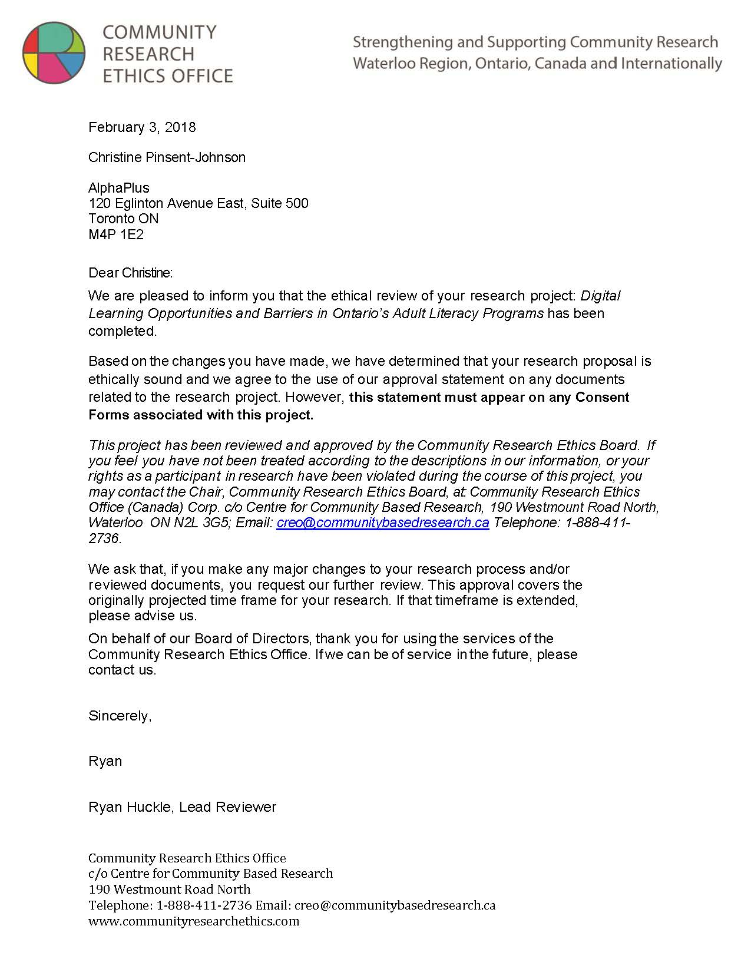

2. Informed Consent and Participants’ Rights Page 1

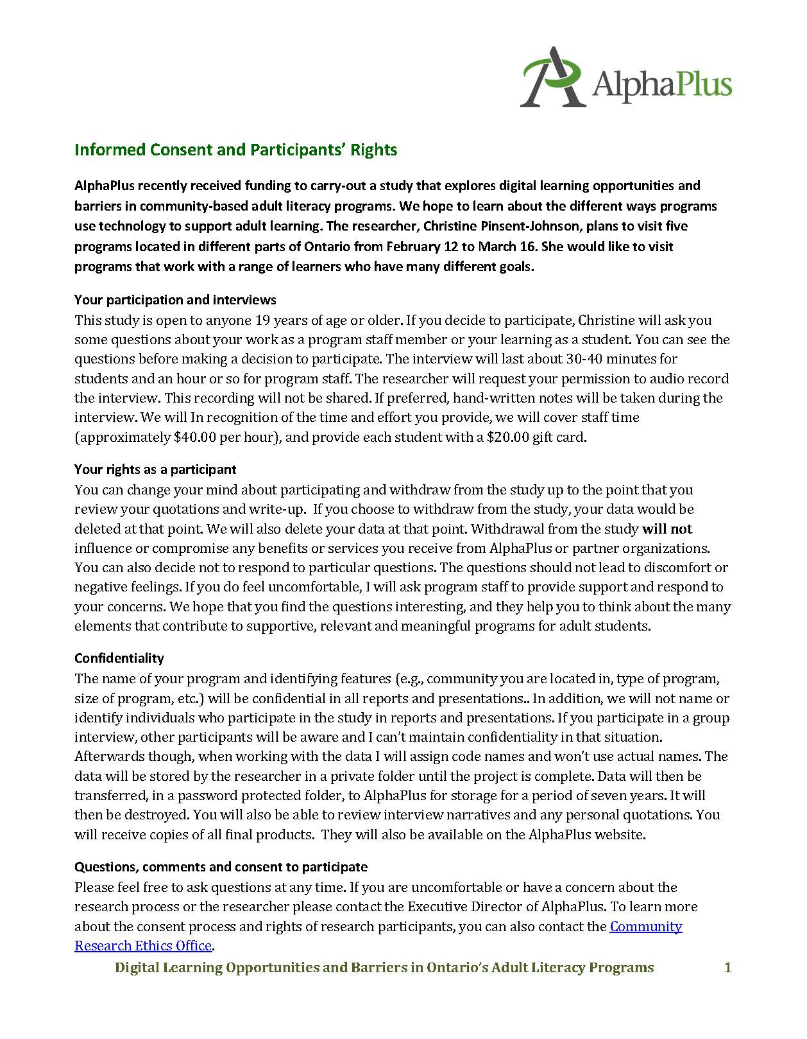

Informed Consent and Participants’ Rights Page 2

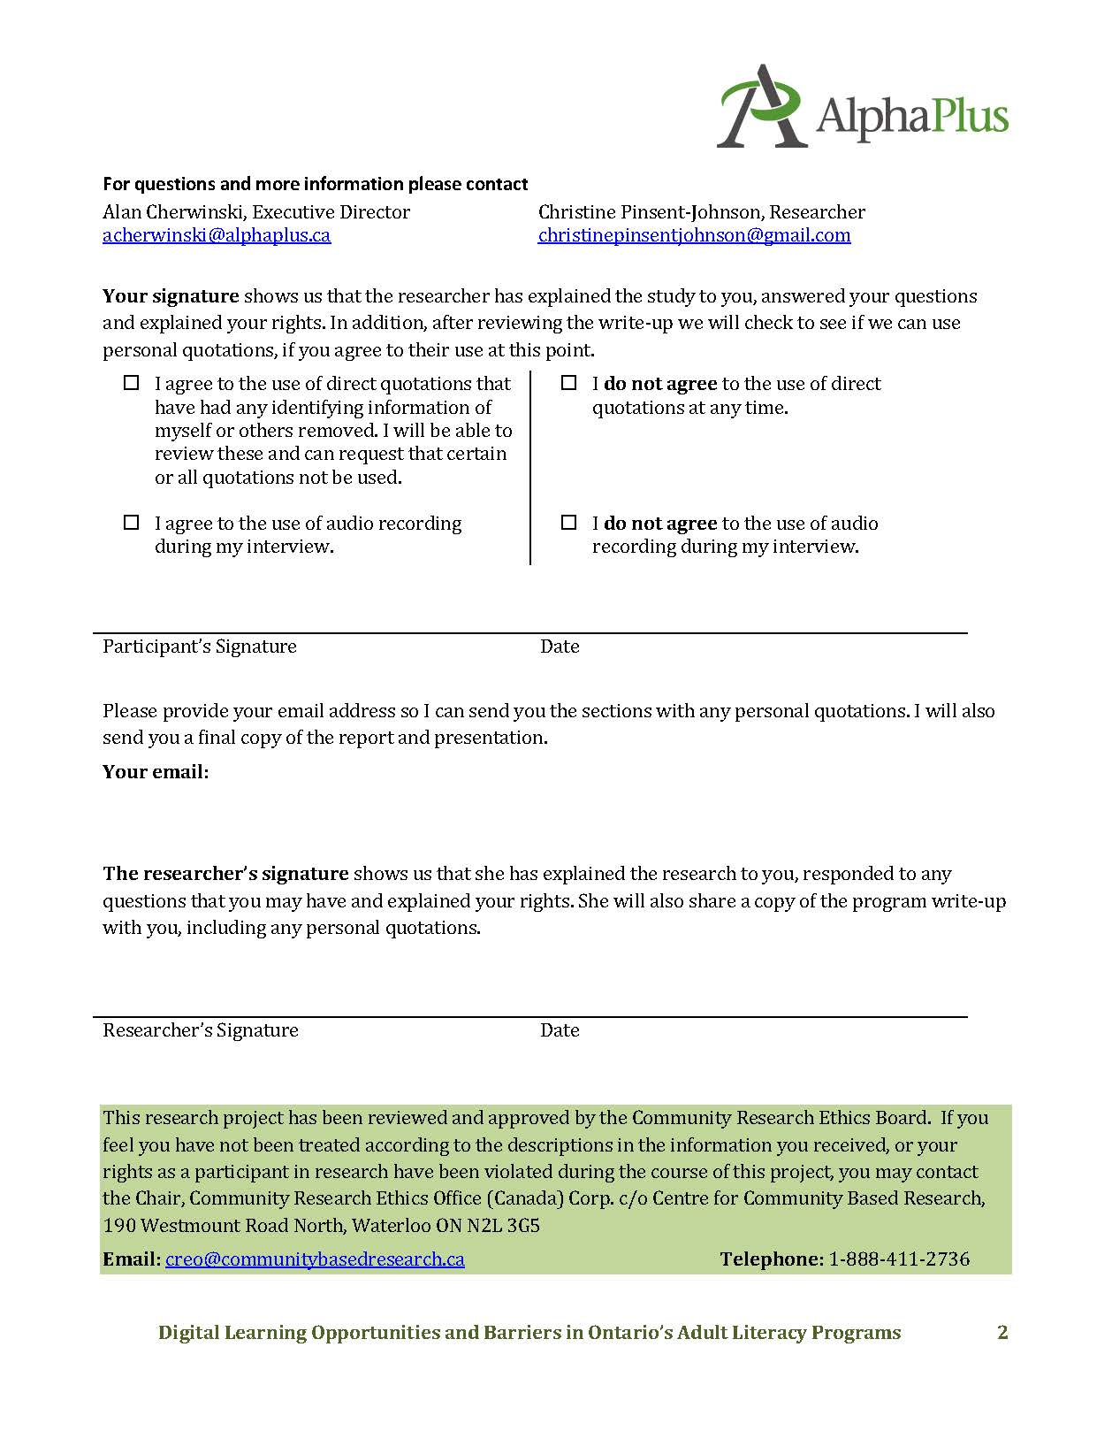

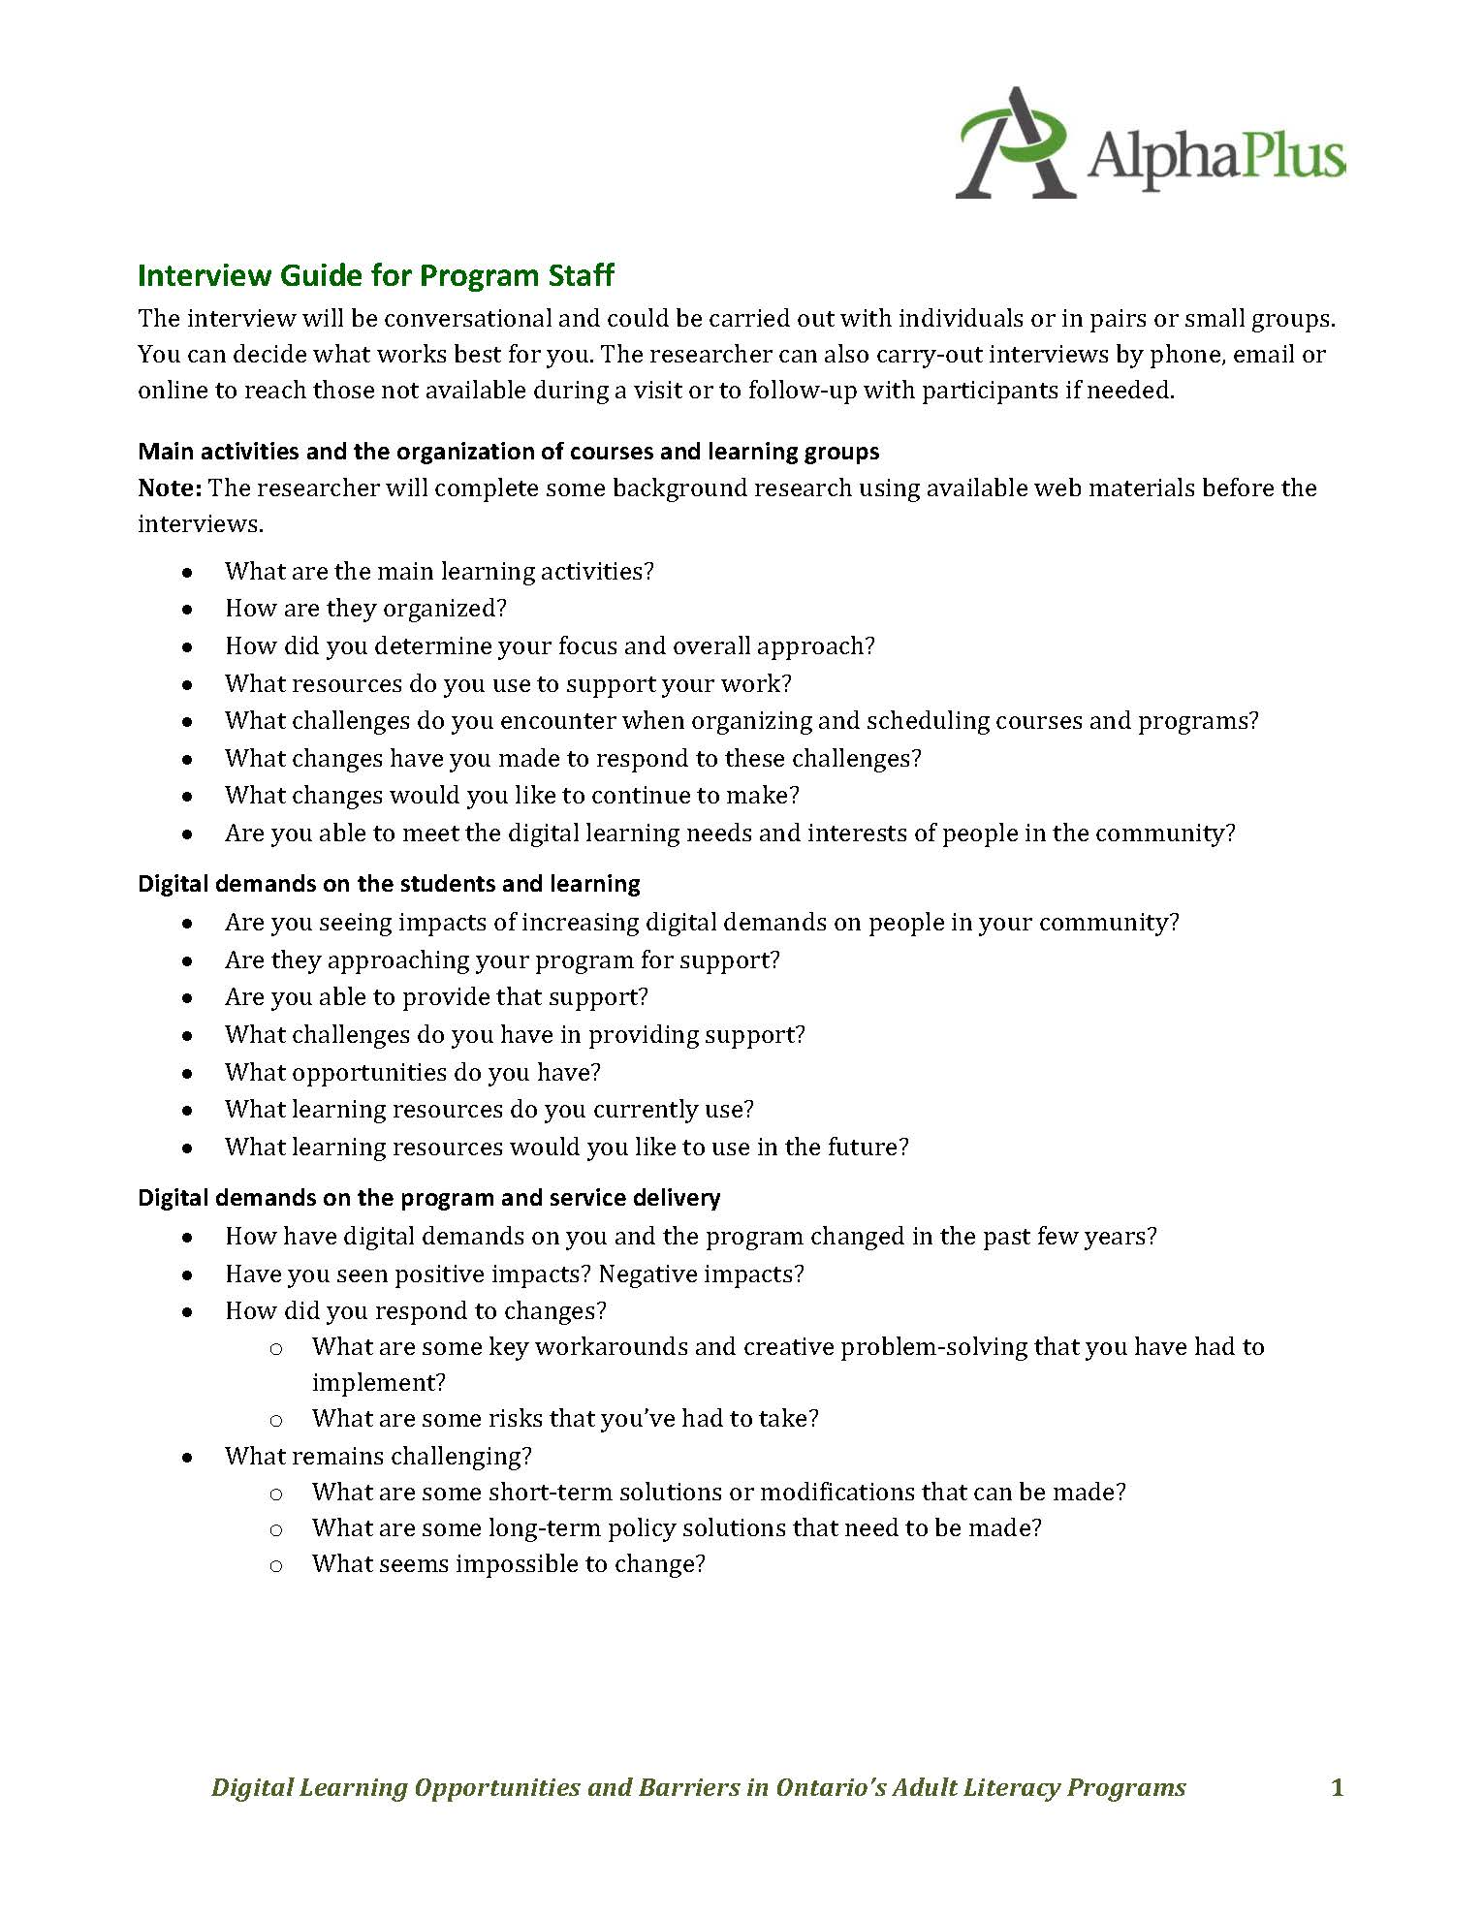
3. Interview Guide for Program Staff

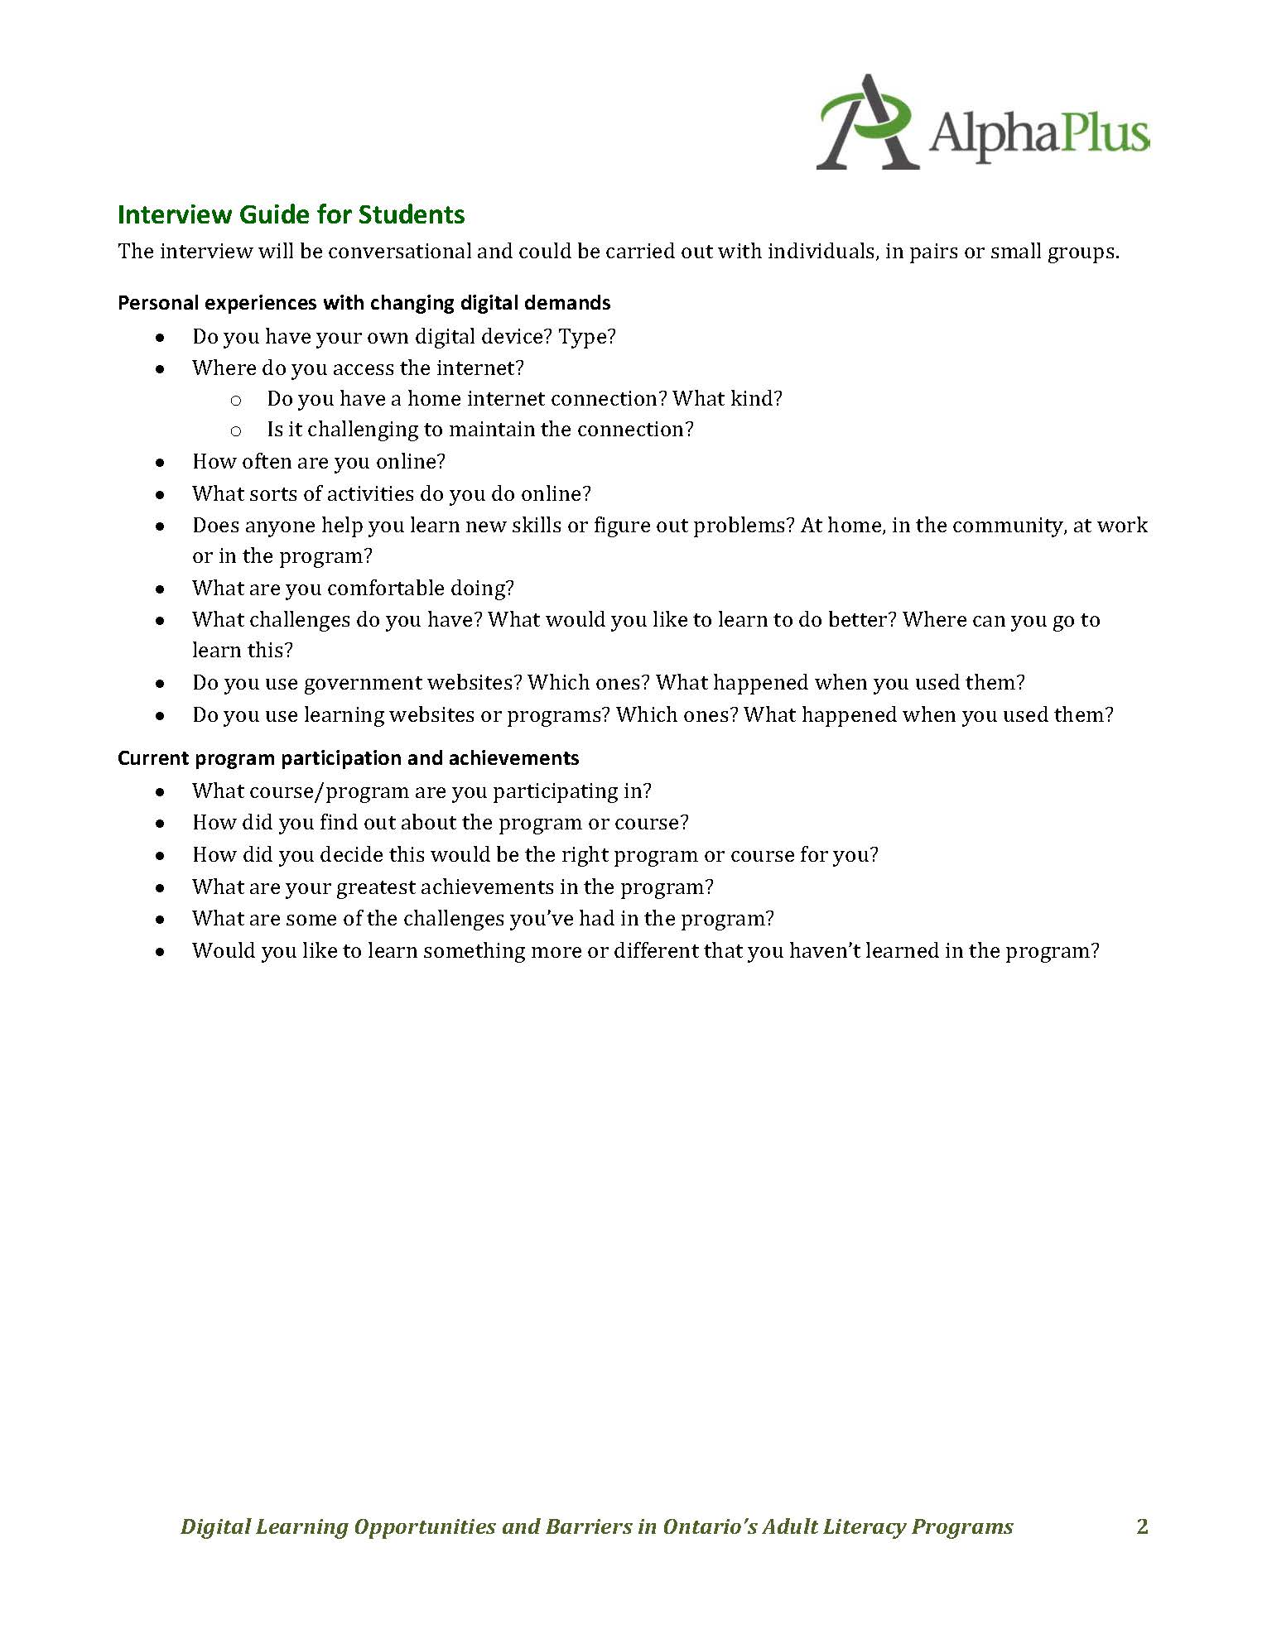
4. Interview Guide for Students

Appendix 2: Program Overviews

Program 1
  - Developing modular courses to support digital literacy and sustain an independent community-based program
During the past two years, Program 1 has been rapidly expanding their selection of modular courses to complement one-to-one and small group programs. These are courses that run over a six-week period for two hours each week. A driving force behind this decision was to reach new students and expand the program using existing resources and expertise, including tutors.
They also wanted to offer their tutors a more flexible and rewarding volunteer experience. The courses can be delivered by tutors in one of the program’s two learning centres or in community locations in partnership with various agencies and organizations. The program manager explained:
We had to think in new ways. That’s why the modular programs were born.

Modular or Short Courses
Modular or short courses run for six to eight weeks using curriculum content developed by staff or occasionally uniquely experienced tutors, and a tutor/mentor teaching model. The following are currently available:
- Customer Service Excellence and Bullfrog Point of Sale
- Computer Basics with Northstar Digital Certification
- Writing for Success
- Reading for Health
In addition, three other courses are under development:
- Workplace or Financial Math
- Employability Success
- Smart Serve Modular Training

Small Groups and One-to-One Tutoring
Learners can also meet regularly in small groups with an instructor or one-to-one with a tutor. Both tailor content and literacy development to individual aims and levels. They engage with technology using what one instructor called a “blended learning” model. This often entails supplementing print-based instructions with online activities.

Program 2
  - Integrating technology to bridge the distance and ensure equitable access to direct instruction and educators
The program serves several small communities in northern Ontario. They have three sites and also provide on-site learning support in four First Nations communities. The greatest challenge is providing access to practitioners and
direct teaching support over vast distances between small communities. One instructor wrote:
As a multi-site organization, our biggest challenge is
co-ordinating/scheduling courses simultaneously and sharing resources across all sites.

Technology-Facilitated Access to Educators and Live Classes
To address the challenges, the program is developing a technology-facilitated model of delivery to provide site-to-site and site-to-home virtual connections in order to provide more consistent access to live classes and instructors at scheduled times. This will help the program use their resources far more efficiently and effectively. This access is supported with webcams, larger monitors, software to facilitate communication and TeamViewer, a desktop-sharing tool that will help instructors provide technical support to participants.

On-Site Workshops and Community Partnerships
Complementing their remote access model are several opportunities for learners to participate in courses to support independence and academic and employment goals, in addition to technology skills.
They offer technology skills development workshops on the following topics:
- Using iPads and tablets.
- Basic computer skills using MS Office.
- Using social media and developing a digital portfolio.
Supporting independence goals is a project with the food bank in which cooking sessions are offered.
Supporting learners with academic goals is a drop-in program run in partnership with a school board with instructional support and child-minding.
The program also supports employment goals, offering on-demand certifications for Smart Serve, Safe Food Handling, Workplace Hazardous Materials Information System (WHMIS), Service Excellence and Soft Skills Solutions. They are also exploring social enterprise opportunities.

Program 3
  - Responding to the community and ensuring inclusion
In the past year, the program has enhanced their traditional one-to-one support model with a series of short courses. This was done to respond to the increase
in requests for computer skill development and to also attract new learners to
the program.

Short Courses
Short computer-basics courses are composed of small groups with four to 10 participants. They usually run for six weeks with one or two sessions per week for
a total of about 36 hours. They can be run on-site or off-site.

One-to-One Support
The program also provides credit support to those working towards their Ontario Secondary School Diploma (OSSD) in partnership with the school board. The students are working on independent courses, either online or in print format. The literacy program staff provide supplemental literacy and numeracy support and also help students navigate the online environment if needed.

Agent for OESP
Also part of their one-to-one model is a formal partnership with a government agency. The literacy program is a recognized agent for the Ontario Electricity Support Program (OESP), offering support to those with low income to complete an application for a hydro rebate.
Future plans include the following:
- More advanced courses using MS Office products.
- A course on Excel combined with personal financial literacy.
- Teaching participants how to transfer what they learn about PCs and the Office/Windows environment to Google Suite.
- A course that looks at online safety, security and privacy, particularly when using social media.
- A course exploring the local community, touching on history, geography and civics.

Program 4
  - Offering a comprehensive range of learning opportunities, including on-site contextualized learning groups to support employment
The employment-focused program has integrated a comprehensive range of learning opportunities, including those that foster belonging, engagement and collaboration among adult learners. Their focus on employment could help people living in poverty pursue opportunities that may have positive impacts in their lives, explained the co-ordinator.
Because we work with adults, and poor adults, we understand that one way out of poverty might be work; so work is a very important potential for
our students.
The program is the largest community literacy organization funded by MAESD and has the resources to support 10 full-time educators in two locations, in addition to support staff, two site co-ordinators and an executive director. The program also has dedicated technical support at each site, a position that is combined with teaching. They have computer labs and recently received new tablets and laptops for use in classes. Technology is integrated within two organizational approaches: (1) educator-led courses and classes and (2) on-site work experience opportunities.

Educator-Led Courses and Classes
The program offers full-time classes that are divided by ability level at each of its two sites. Teaching staff develop their own technology integration approaches based on their student group and their own evolving repertoires of skills, knowledge and capabilities. They have expanded their technology repertoires on their own and in collaboration with other educators, including dedicated tech educators. They also collaborate with the digital technology educator in the computer lab to support larger projects.

On-Site Work Experience Opportunities
Integrated into the program is an innovative on-site work experience and learning opportunity, which also includes various technologies. All students participate in small groups or teams to support the operation of a snack and lunch counter and to plan events. In addition to providing an opportunity to gain work experience, participants have an opportunity to develop interpersonal skills along with communication, planning and problem-solving strategies. As an authentic on-site learning opportunity, their activities, decisions and communication have actual consequences and serve a meaningful purpose. Technology is seamlessly integrated into the activities and serves as both a means of support for literacy and numeracy (e.g. using a spreadsheet to make a budget) and as a primary learning activity
(e.g. learning to use a point-of-sale system).

Program 5
  - Innovative and creative classes informed by social-justice pedagogies supporting community development and individual transformation
Program 5 has developed programs using both MAESD and additional funding sources, including corporate funding. They are able to integrate technology in very innovative and inclusive ways using multiple funding sources. The co-ordinator summarized the program approach:
Our staff look at people as a whole person, which includes their communities.
How do we build strong communities together? Everything we do has to have impact not only in the classroom but also in the community. How do the
learners we are engaged with take back what they learn
to the community?

Academic Upgrading with Regularly Scheduled Classes
Students attend the academic upgrading program five hours per day. Classes focused on communications, numeracy, language arts and digital technology are facilitated by individual instructors, and students follow a weekly schedule. Students are not divided by levels within the learning groups. They all participate in group discussions and activities, and particular assignments and expectations are individualized to their abilities.
- Communication projects: A core part of the academic upgrading program is a comprehensive communications project completed each semester.
- Digital technology class: Within the academic upgrading program is a dedicated digital-technology class. Depending on the learner group, they will pursue various topics.
- Motivational learning workshops: Every Friday, academic upgrading students take a break from the regular schedule and participate in workshops, often run by community partners.

Summer Courses and Short Courses
The program has also developed a series of summer workshops and short courses to complement their regular programs. These often attract new learners and provide continuing learners with a change.
The program also offers additional opportunities using funding from other sources: (1) social incubators related to catering and sewing, (2) a youth mentorship program to support digital literacy among adults who may also be developing language and literacy and (3) a leadership development program for
immigrant women.

Program 6
  - An inclusive and individualized program in a multi-service
support agency
The program is part of a multi-service support agency providing a range of supports, including housing, employment and well-being in a city outside the GTA. It is centrally located and easily accessible by public transit for all who wish to attend. The co-ordinator explained that the program’s inclusiveness, flexibility with continuous intake and individualized attention make it work for people.
People are attracted to the community-based
model, especially if they need flexibility and
wraparound supports.
The literacy program instructors work closely with the employment services counsellors, providing combined supports for those seeking employment. In addition, the employment resource room is open for anyone to use, including those who may not be actively seeking employment but need access to resources and technology to complete applications and paperwork related to housing, income supports and pensions.
This sort of community access was once part of the federally funded Community Access Program, which ended in 2012. “The need is still there,” stated the co-ordinator. Clients can use the photocopiers, scanners and computers free of charge. The resource centre counsellors may refer individuals to the literacy program.
The employment application process has become complex over the years,
explained an educator, and now demands comprehensive literacy, technology
and cultural knowledge.

Program Components
In response, the literacy program integrates various program delivery models to provide responsive, individualized supports while working with the employment resource centre, other community partners or independently in their learning area, referred to as a training room.
- On-demand and responsive support for individuals or pairs.
- Individualized computer training using detailed skills checklists to determine current skills and skills the client would like to acquire.
- Small group sessions to focus on more comprehensive skill development to prepare for secondary and post-secondary education.
- Access to certifications for WHMIS and health and safety training, also access to Safe Food Handling with TrainCan Inc. and Soft Skills Solutions through program trained instructors.

Appendix 3: Overview of Applications Mentioned

To learn basic skills to access technology
GCFLearnFree.org
Northstar Digital Literacy Assessment Project
ABC Life Literacy Canada Internet Matters
Gmail

To support literacy, numeracy and communication
Academy of Reading
ReadTheory
Purdue Online Writing Lab
FreeRice.com
Chomp Chomp
ABC Life Literacy Canada Money Matters

To support employment
MS Office
MS Outlook
Outlook Teams
Magnet, a job matching site for those facing barriers to employment
Safe Food Handling with TrainCan Inc.
Soft Skills Solutions

To support teaching and sharing ideas, information and knowledge
(used by students and teachers)
Canva or Photofox
Explain Everything
Google Classroom
Edpuzzle
ClipGrab, to insert YouTube videos directly into presentations
Google Docs
PowerPoint or Google Slides or Prezi
Padlet

Knowledge about Indigenous peoples
Whose Land allows one to see which Indigenous communities have lived in a specific area.
First Story (a blog) and the accompanying Driftscape app are similar, but related to the GTA

Refer to Digital Government: Making Government Work Better for People in the Digital Age. The Government of Ontario, 2017.
From 2015-2016 LBS Data Summary.
More than digital literacy and access to infrastructure is needed to address a digital divide that is also a socio-economic divide argue researchers who examined “social exclusion in the information age.” Digitally marginalized adults need policy supported opportunities to access and develop of full range of digital human capital and citizenship competencies that facilitate engagement in communities, cultural life and institutional domains. From Digital Human Capital: Developing a Framework for Understanding the Economic Impact of Digital Exclusion in Low-Income Communities by Amy Bach, Gwen Schaeffer and Todd Wolfson. Journal of Information Policy [open access], Vol. 3, 2013.
Deborah Brandt has examined the role of literacy (print and digital forms) in people’s lives within the context of socio-economic change of the past century. Her most recent work argues that it is writing more than reading that has become the more valuable literacy commodity in the 21st century. See The Rise of Writing: Redefining Mass Literacy by Deborah Brandt. Cambridge University Press, 2014.
Refer to Digital Government: Making Government Work Better for People in the Digital Age. The Government of Ontario, 2017.
As above.
Refer to Digital Opportunities and Barriers for Ontario’s Disconnected Adults [full report and webinar] by Christine Pinsent-Johnson and Matthias Sturm. AlphaPlus, 2017.
Case studies of each program can be accessed here.
The OECD has been involved with or overseen a series of international adult literacy assessments since the early 1990s. The third round of testing, the Programme for the International Assessment of Adult Competencies (PIAAC), included an online reading and computation component called problem-solving in technology-rich environments (PS-TRE). Although the test construct is limited in what it can tell us about digital literacy development, results are correlated with a range of socio-economic variables that help to illustrate the digital divide. Refer to Skills in Canada: First Results From the Programme for the International Assessment of Adult Competencies (PIAAC).
From Revisiting the Digital Divide in Canada: The Impact of Demographic Factors on Access to the Internet, Level of Online Activity, and Social Networking Site Usage by Michael Haight, Anabel Quan-Haase and Bradley Corbett. Information, Communication & Society [abstract], 2014.
From Household Internet Rates from Canadian Internet Use Survey, 2012. Statistics Canada, 2013.
From The Digital Divide Shifts to Differences in Usage by Alexander JAM van Deursen and Jan AGM van Dijk. New Media & Society [abstract], 2014.
From Public Perspectives: Participation in the Digital Economy 2.0: Summary Profile of Very Low, Low and Moderate Internet Users. Ipsos, 2016.
From Levelling Up: The Quest for Digital Literacy by Analise Huynh and Nias Malli, Brookfield Institute, 2018.
From There’s an App for That. Unless There Isn’t — The Challenges of Digital Inclusion in Canada in 2016 by Catherine Middleton [lecture]. Big Thinking Lecture, 2016.
From What Good is Declaring Broadband a ‘Basic Service’ Without Regulating Retail Prices? CBC News, December 2016.
From Digital Literacy Exchange Program. Innovation, Science and Economic Development Canada, 2018.
Graphic from A Brief Introduction to Adult Education in Ontario [blog]. Code for Canada, March 2018. Graphic originally appeared in Strengthening Ontario’s Adult Education System: A Discussion Paper to Guide Public Consultation (page 15). Government of Ontario, 2017.
LBS also provides access to online learning opportunities to learners across the province through its e-Channel system. We did not look at this aspect of LBS, as the focus is on direct delivery and face-to-face learning opportunities. More information about e-Channel can be found here.
Recently completed research and program evaluations indicate that changing accountability demands may be reshaping who programs serve, possibly restricting their inclusivity. Refer to the following: Evaluation of the Literacy and Basic Skills (LBS) Program Final Report from Cathexis Consulting, 2016; Negotiating Responsibilization: Power at the Threshold of Capable Literate Conduct in Ontario by Tannis Atkinson, 2013; Managing and Monitoring Literacy for a ‘Knowledge Society’: The Textual Processes of Inequality in Adult Education Policy, Pedagogy and Practice by Christine Pinsent-Johnson, 2014; Neoliberal Conceptual Framing and the Disappearing of Marginalized Adults from the Basic Adult Education Learning Landscape in Ontario by Laura Wyper, 2018.
From Learning Together with Technologies: Illustrative Case Studies. AlphaPlus, 2012.
From LBS IT Refresh Announcement [memo]. Government of Ontario, 2018.
From LBS Improvement and Expansion Qs & As. Government of Ontario, 2017.
The study design, data collection and analysis were informed by Multiple Case Study Analysis [overview] by Robert Stake. Guilford Press, 2006.
Case studies can be accessed here.
In 2015-2016, 13,000 adults attended community programs, representing 30% of total enrolments in LBS.
From Digital Human Capital: Developing a Framework for Understanding the Economic Impact of Digital Exclusion in Low-Income Communities by Amy Bach, Gwen Schaeffer and Todd Wolfson. Journal of Information Policy [open access], Vol. 3, 2013.
Based on 2015-2016 data compiled from EOIS-CaMS, providing a provincial overview.
From Digital Equity Action Plan (DEAP). City of Portland, 2016.
E-Channel is funded by LBS to develop and deliver courses using an online learning model. Four different providers are contracted, and approximately 4,000 learners per year participate.
Image and description of digital literacy development from Levelling Up: The Quest for Digital Literacy (page 5) by Analise Huynh and Nias Malli, Brookfield Institute, 2018.
Victoria Purcell-Gates, a literacy researcher formerly at the University of British Columbia, did an extensive study of pedagogical approaches in U.S. adult basic-education programs in the early 2000s. She and her team developed two organizing categories to describe broad pedagogical approaches — contextualized/dialogic and decontextualized/monologic — which I have adapted.
For a more comprehensive overview of AlphaRoute, an online learning portal that was used in Ontario and across Canada from 1996-2008, refer to Effective Literacy Practice: AlphaRoute, UNESCO Institute for Lifelong Learning.
Graphic from What Is the SAMR Model? Wikiversity, 2018.
From How to Apply the SAMR Model With Ruben Puentedura [video]. Commonsense Education, 2016.
The collection is now hosted by Le Centre de documentation sur l’éducation des adultes et la condition féminine (CDÉACF) at http://library.copian.ca/. However, there is no ongoing funding available to update or maintain the collection.
From Digital Curation as a Core Competency in Current Learning and Literacy: A Higher Education Perspective by Leona Ungerer. The International Review of Research in Open and Distributed Learning, 2016.
The OALCF comprises a skills standards framework across three levels and five main domains and two mandated assessment tools. The milestones comprise 64 mini-tests that are intended to be used to demonstrate progress. More lengthy culminating tasks, combining various skill domains, are intended to be used to demonstrate a learner’s readiness to pursue his or her goal related to further education, employment and independent living. Neither the milestones nor culminating tasks have been validated for these intended purposes.
See Practices Developed When Using the OALCF Milestones.
The study design, data collection and analysis were informed by Multiple Case Study Analysis by Robert Stake, 2006.

